PARTICIPANT INFORMATION SHEET
Discourse, Interaction, Support and Communication Outcomes in Virtual Reality for People with Post-Stroke Aphasia (DISCOVR Aphasia) (ETH24-9754)

WHO IS DOING THE RESEARCH?
We are a team of 6 researchers.
We are 4 speech pathologists, a physiotherapist, and an orthoptist.
Dr Lucy Bryant  (speech pathologist at UTS)  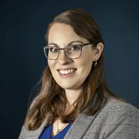 | Dr Brielle Stark  (speech pathologist from the USA)  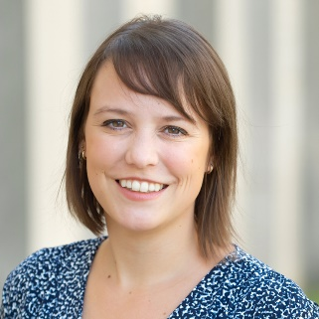 | Professor Emma Power  (speech pathologist at UTS)  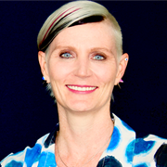
Dr Peter Stubbs  (physiotherapist at UTS)  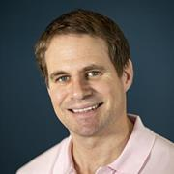 | Dr Vincent Nguyen  (orthoptist at UTS)  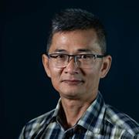 | Professor Bronwyn Hemsley  (speech pathologist at UTS)  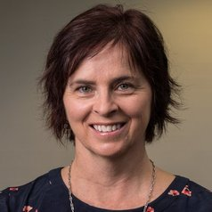

WHAT IS THIS RESEARCH ABOUT?
Aim: To understand how people with aphasia talk and move in virtual reality.
We want to know how virtual reality can help with rehabilitation.
Virtual Reality uses glasses to make you feel like you are somewhere different.  It is like being inside the picture on your TV. | 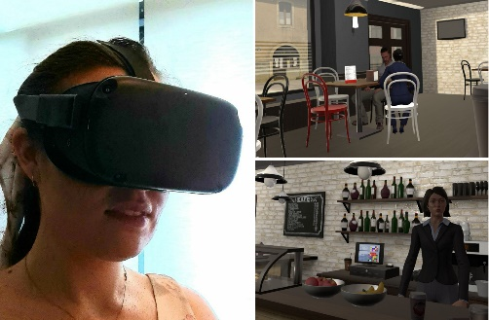
Why?  - Virtual Reality can help with assessment and therapy  - It might help with safe practice of talking  - We need to make sure it works before people use it | 
How? You will watch videos and talk to people in virtual reality.
We will ask you questions about it and listen to your talking.

WHY HAVE I BEEN ASKED?
We want people with aphasia to join the study  You had a stroke.  You have difficulty with talking and understanding.  You want to try virtual reality. | 

WHAT WILL I HAVE TO DO?
You will do these things if you want to participate:
We will have a video call with you to ask you some questions.  We will ask about you.  We will ask you about virtual reality to make sure it is safe for you to use.  This will take 20 minutes |   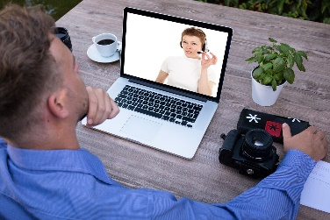  20 mins
You will visit The University of Technology Sydney.  We will do an assessment of your aphasia.  Then you will use the Virtual Reality glasses.  You will watch 2 videos and play 2 games.  We will ask you questions about using Virtual Reality.  We will record you on video while you do these things.  This will take about 2 hours. | 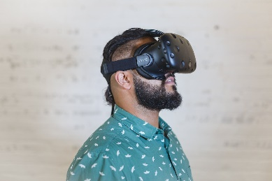  2 hours

ARE THERE ANY RISKS/INCONVENIENCE?
You could be uncomfortable when you use Virtual Reality.  You can tell us if you are uncomfortable, and we will stop.  Using Virtual Reality might make you tired. We can have a break if you are tired. | 
Some people feel sick when they use Virtual Reality.  We will watch closely and ask questions about sickness while you use Virtual Reality.  We will stop if you feel sick. | 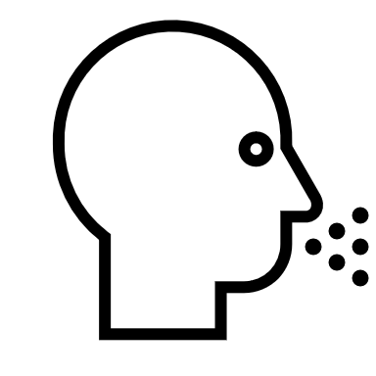
You will be sitting down when you use Virtual Reality so that you don’t fall over. | 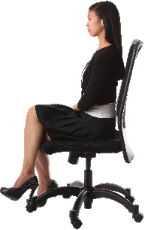

DO I HAVE TO SAY YES?
You can choose if you want to participate in this research.  You can say no.  If you say no, it will not affect your relationship with the research team or UTS. | 

WHAT IF I WITHDRAW FROM THE RESEARCH?
You can stop the research at any time.
You can tell the researcher that you want to stop at any time.
You can send the researcher an email at lucy.bryant@uts.edu.au
You can choose to take your data out of the study when you stop. We have to keep your consent form by law. We will destroy all other data.

WHAT HAPPENS TO INFORMATION ABOUT ME?
You agree to let us collect and use your personal information for the research when you sign the consent form. | 
All of your information will be treated confidentially.  Information and video recordings that identify you will be stored separately.  All the information will be stored at UTS. Only the researchers will be able to see it. | 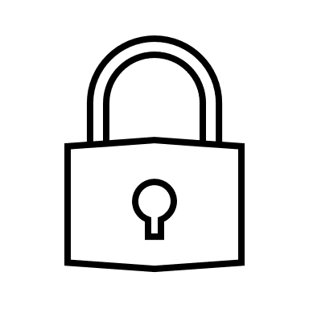  
We have to keep your information for 7 years. After 7 years, we will destroy it. | 
We expect to publish the results from this study in articles and presentations. You will not be able to be identified from these publications. | 
You have a right to request information that is collected and stored by the research team, in line with Australian and NSW Privacy laws. Please tell us if you want to see your information. | 

WHAT IF I HAVE CONCERNS OR A COMPLAINT?
Contact Lucy if you have any questions or concerns.  Lucy.Bryant@uts.edu.au | 
This study has been approved by the University of Technology Sydney Human Research Ethics Committee.

If you have any concerns about the research and you want to talk to someone outside of the research team, you can contact the Ethics Secretariat at +61 2 9514 2478 or email research.ethics@uts.edu.au.

Communication Accessibility
We have followed Rose et al.’s (2012) guidelines to make this document easy to follow.
Rose, T. A., Worrall, L. E., Hickson, L. M., & Hoffmann, T. C. (2012). Guiding principles for printed education materials: Design preferences of people with aphasia. International Journal of Speech Language Pathology, 14(1), 11–23. https://doi.org/10.3109/17549507.2011.631583
CONSENT FORM
Discourse, Interaction, Support and Communication Outcomes in Virtual Reality for people with Aphasia (DISCOVR Aphasia) (ETH24-9754)

Tick each item if you agree.
 | I, __________________________ (name), agree to participate in the Virtual Reality research project at the University of Technology Sydney | ☐
 | I have read the information sheet. I understand:  - Why the research is being done.  - What I will do in the research.  - The risks of the research. | ☐
 | I know I will be recorded as part of the project. | ☐
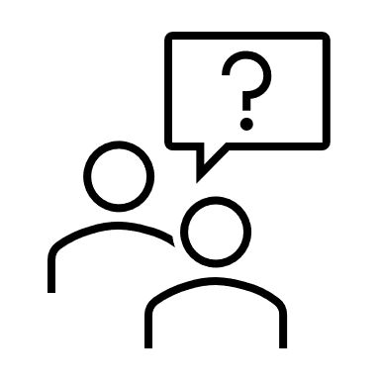 | I have asked questions, if I was not sure about anything.  I am happy with the answers. | ☐
 | I freely agree to participate in the research. I know I can leave the study at any time. Leaving will not affect my relationship with anyone on the research team or UTS. | ☐
 | I know I will be given a signed copy of this consent form to keep. | ☐
 | I know that I can contact Lucy Bryant if I have any concerns about the research. If I want to speak to another person I can contact the Ethics Secretariat at +61 2 9514 2478 or email research.ethics@uts.edu.au. | ☐

Please sign here.

Participant name: ____________________________ | Date: ____/____/____
Signature [participant]: _______________________

Name: _____________________________________ | Date: ____/____/____
Researcher signature: _________________________

Name: _____________________________________ | Date: ____/____/____
Witness* signature: ___________________________

Witness to the consent process
If the participant, or if their legally acceptable representative, is not able to read this document, this form must be witnessed by an independent person over the age of 18. In the event that an interpreter is used, the interpreter may not act as a witness to the consent process. By signing the consent form, the witness attests that the information in the consent form and any other written information was accurately explained to, and apparently understood by, the participant (or representative) and that informed consent was freely given by the participant (or representative)

