
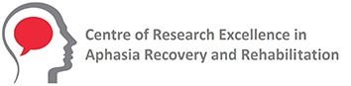
Seeking people with aphasia after a stroke
for a research project

Aphasia-DOOR: Your Voice in Measuring Research Success

What is this research about?
We want to make a better way to check if aphasia therapy really helps.
The problem:
Many tests check only ONE thing.
But aphasia affects many parts of life.

What is different?
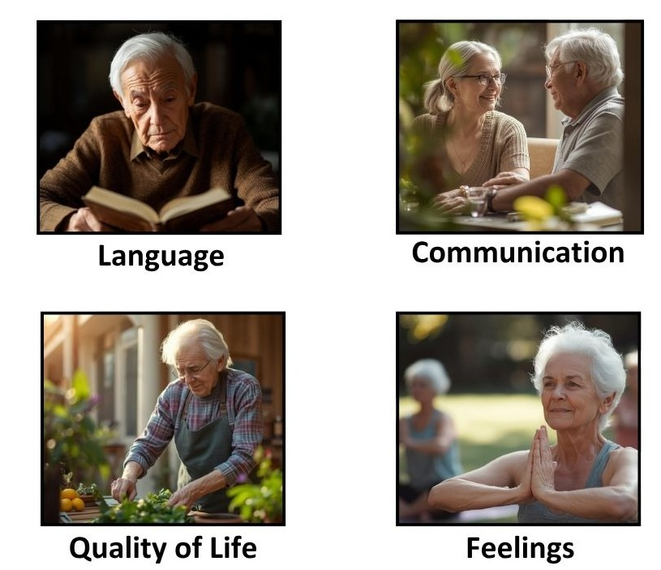
This time you tell us
What is important to you!

Why does this matter?
Your voice helps us measure therapy success in future aphasia research
Bottom line:
You are the expert.
We need your help to build a better tool

What will I need to do?
1: Get ready
Watch short videos about the research

Read aphasia-friendly information
2: Talk with us
Interview: 1 hour online (just you)
Group talk: 2 hours online (small group)

What will we talk about?
✓ Your story with aphasia therapy
✓ What matters most to you in aphasia therapy
✓ What is important to you in aphasia recovery
Who can participate?
Aphasia after stroke
Have had aphasia for 6+ months.
Previous therapy OR research experience (not only aphasia)
Can join online
Age: 18+
Live in Australia

Payment
You will get paid for your time

Please scan the QR code to:
Read more information
Register your interest

Want to hear more about this research?
Contact Associate professor Annie Hill
Phone: 0394791887
Email: AphasiaDOOR@latrobe.edu.au

Principal Investigator: Dr Annie Hill La Trobe University

This study has received ethical approval (HEC25225) from La Trobe university

