**Participant Information Sheet**

**Research Title: Returning to driving or not for people with aphasia following stroke: An international survey of multidisciplinary team perspectives, practice, and experience.**

**Lay Title:** A multinational survey of healthcare team opinions, practices, and experiences about people with aphasia returning to driving after a stroke.

**Researcher(s):**

A/Prof. Sarah Wallace1,2

Dr. Hannah Gullo3,4

Prof. David Copland1,2

Helen Wallace1,2

1 Queensland Aphasia Research Centre, School of Health and Rehabilitation Sciences, University of Queensland, Brisbane, Queensland, Australia.

2 Surgical Treatment and Rehabilitation Service (STARS), Education and Research Alliance, The University of Queensland and Metro North Health, Brisbane, Queensland, Australia.

3 Occupational Therapy, School of Health and Rehabilitation Sciences, The University of Queensland, St Lucia, Queensland, Australia.

4 Allied Health Research Collaborative, The Prince Charles Hospital, Metro North Health, Brisbane, Queensland, Australia

**Thank you** for your interest in participating in this research project. Please read the following information about the project so that you can decide whether you would like to take part. Please feel free to ask any questions you might have about our involvement in the project.

If you choose to participate in this research, please remember that your participation is completely voluntary. You are not required to take part if you don't wish to. If you decide to participate but later change your mind, you can stop and exit the survey at any time, without needing to provide any reason. However, since the data collected is non-identifiable, individual responses cannot be removed from the dataset once entered. Survey responses where at least one question, along with the demographic questions, are completed will be included. As this research involves non-identifiable responses, we won’t be able to identify or remove your individual responses once they are submitted. **By participating, you are consenting to the collection of your non-identifiable survey responses.** Your choice to participate, decline, or exit the survey at any point will not affect your relationship with the University of Queensland

**What is this research about?**

This research aims to explore the **perspectives**, usual **practice** and **experiences** of professionals who contribute to the assessment of return to driving for people with aphasia after stroke. This includes both the stroke healthcare team, and other professional groups involved in the assessment of fitness-to-drive.

Around one third of stroke survivors live with aphasia and have difficulties with their language and communication after stroke. People with aphasia, their caregivers and clinicians have identified return to driving as a top 10 priority, and recent research suggests this may be particularly challenging for people with aphasia. Although it remains unclear as to whether or not aphasia may impact driving safety; people with aphasia face unique challenges in returning to driving due to: (1) uncertainty regarding the role of language in driving; (2) poor awareness and understanding of aphasia, and (3) communication demands in the patient-journey and routine. You have been asked to participate because in your professional role, you may be involved in assessing the fitness-to-drive of clients with aphasia after their stroke.

This research is being completed as part of Helen Wallace’s PhD with the University of Queensland investigating “What is the best way to help people with aphasia to return to driving after stroke.” Helen Wallace has an Australian Government Research Training Program Scholarship to support her PhD studies and A/Prof. Sarah Wallace has a National Health and Medical Research Council Emerging Leadership Investigator Grant. However, no specific funding has been assigned to this project.

**What will I need to do?**

You will be asked to respond to an **online survey** exploring your perspectives, usual practice and experience regarding return to driving for people with aphasia following stroke. The survey will take approximately 15 minutes to complete.

**What are the possible benefits of taking part?**

Although you will not receive direct benefits from participating in this study, your contribution will be greatly valued and will support one of the top 10 research priorities for individuals with aphasia, their caregivers and clinicians. It is hoped that this research will improve our understanding of how assist people with aphasia to return to driving after stroke.

**What are the possible risks and disadvantages of taking part?**

There are no foreseeable risks, beyond inconvenience, to taking part in this study.

**What will happen to the information about me?**

All data and documentation collected during your participation will be stored electronically and password-protected, in accordance with The University of Queensland's Research Data Management Policy. The university uses a secure system, Research Data Manager, to store human research data. Your non-identifiable data will be kept within this system, and only authorized project staff with the appropriate permissions will have access. Should you choose to provide your email address to receive a copy of the results, this information will be stored in a separate, password-protected file containing re-identifying codes, which will also be stored in the Research Data Manager and accessible only to project staff. Data will be retained according to University of Queensland Policy 4.20.06 and the S601.3/C149 of the University Sector Retention and Disposal Schedule, which currently require retention for at least five years after the project ends. After this period, the data may be disposed of if no longer needed. Survey results will be presented in de-identified form in any publications or presentations.

**What will happen if I decide to withdraw?**

Your participation in this research is voluntary. You are free to withdraw at any time without providing an explanation. There will be no penalty or bias as a result of your withdrawal, and it will not impact any future involvement with The University of Queensland. The survey will only collect non-identifiable responses, which cannot be identified or removed from the dataset once entered.

**Can I hear about the results of this research?**

If you would like to receive a written copy of the study results, you can provide your email address prior to entering the survey. The results will be sent to you once the study is complete. De-identified survey results will be included in Helen Wallace's PhD thesis and shared through relevant academic journals and conferences.

**Who can I contact if I have any concerns about the project?**

This study adheres to the Guidelines of the ethical review process of The University of Queensland and the National Statement on Ethical Conduct in Human Research. Whilst you are free to discuss your participation in this study with project staff (email: helen.wallace@uq.edu.au), if you would like to speak to an officer of the University not involved in the study, you may contact the Ethics Coordinator on +617 3365 3924 / +617 3443 1656 or email [humanethics@research.uq.edu.au](mailto:humanethics@research.uq.edu.au)

This is the research Ethics ID number: [To be completed on receipt of ethics approval]

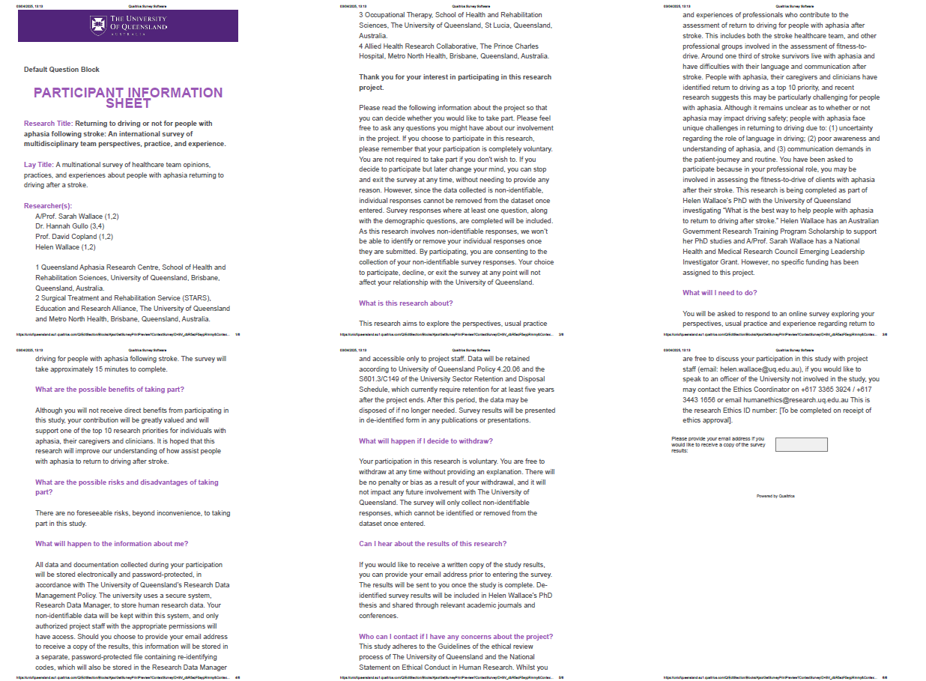**Participant information sheet – Qualtrics view**