MONASH UNIVERSITY STUDY ON COPING AFTER BRAIN INJURY
Monash University are conducting a research study into the experiences of adults (18 years and older) who have had an acquired brain injury (ABI).
We are particularly interested in hearing from people who have had an ABI and have, at any time after their injury, experienced:
- mental health challenges, for example - feeling depressed, anxious or overwhelmed,
- thoughts about suicide or hurting yourself,
- intentional self-harm,
- or, coping strategies that supported mental health and wellbeing since your injury
We understand that these can be difficult things to think or talk about. There is no obligation to do the study. If you choose to take part in the study, the information you choose to share will be used to help improve understanding and support for others who have been through the same. We want to listen and learn from people who have lived experiences, and we will use what we learn to develop resources for the community.
ANONYMOUS SURVEY:
The survey takes about 30 minutes to complete.
Here is the link: https://redcap.link/abicopingsurvey
If you would like assistance completing the survey, please reach out to us at abicoping@monash.edu

IS THIS A GOOD TIME FOR YOU?
- Participating in this study is voluntary. There is no obligation.
- It may be better not to take part right now if you are feeling very distressed, unsafe, or already dealing with a lot.

- If you feel unsure but pressured to take part because it feels like “the right thing to do”, it may not be the right time. You come first.

- Many people find talking about mental health helpful. Sometimes it can also bring up difficult or unexpected feelings. It may help to think about who you would reach out to for support. If you don’t feel able to reach out, it may not be the right time to do the study.

ANY QUESTIONS?
Contact abicoping@monash.edu or call 9426-8923.

MENTAL HEALTH SUPPORT
IF YOU NEED SUPPORT:
- Talk to someone you trust
- Talk to your doctor (general practitioner) about how you are feeling
- Ask for a Mental Health Care Plan from your doctor. They will assess your mental health and create a plan with goals and a referral to a psychologist or other mental health professional for subsidised sessions (up to 10 individual/group sessions per year via Medicare).
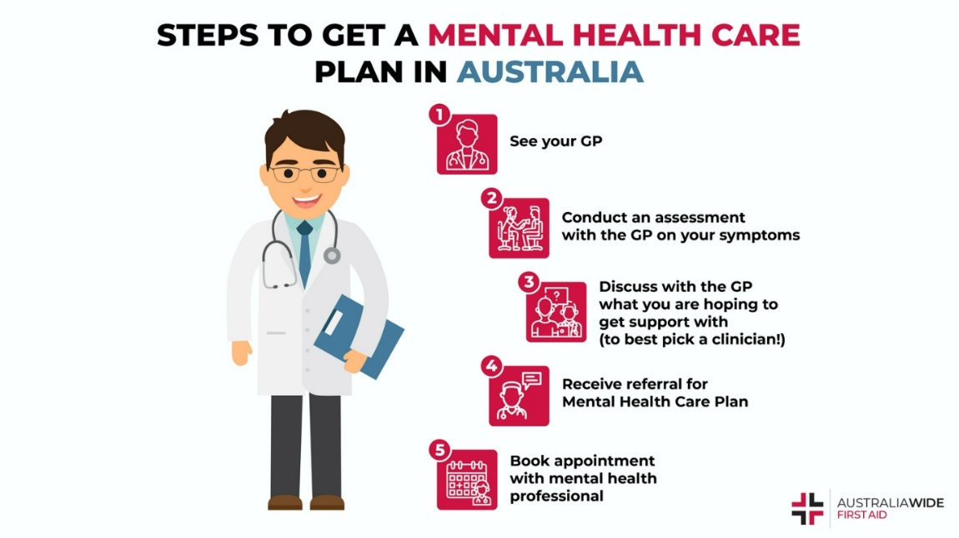
HELPLINES:
SERVICE | PHONE NUMBER | WHO THE NUMBER IS FOR
Triple Zero | 000 | If your life is at risk right now
Lifeline | 13 11 14 | For crisis support
SuicideLine | 1300 651 251 | For support to address distress or thoughts of suicide
Suicide Call Back Service | 1300 659 467 | For support to address distress or thoughts of suicide
Nurse-on-Call | 1300 60 60 24 | If you are not in immediate danger but you need help
Beyond Blue | 1300 224 636 | For mental health support
13YARN | 13 32 16 | For Aboriginal and Torres Strait Islander people
Rainbow Door | 1800 729 367 | For LGBTIQA+ people who need support
SHARC | 1300 660 068 | For people living with or recovering from addiction
Open Arms | 1800 011 046 | For veterans or ex-service people who need support

FUNDED SUPPORT:
- If your injury happened as a result of a motor vehicle accident in Victoria, you may have a claim with the Transport Accident Commission (TAC). In some cases, the TAC can help fund mental health support related to your injury. You can contact the TAC on 1300 654 329. A health professional can also put in a request for support on your behalf.
- If you receive funding through the National Disability Insurance Scheme (NDIS), you may also wish to talk with your support coordinator about whether mental health support could be included in your plan.

