iTakeCharge Study
Virtual Assistant to support Stroke Survivor rehabilitation
PARTICIPANT INFORMATION STATEMENT – Stroke Survivors
(V6_04072025 Stroke Survivors)

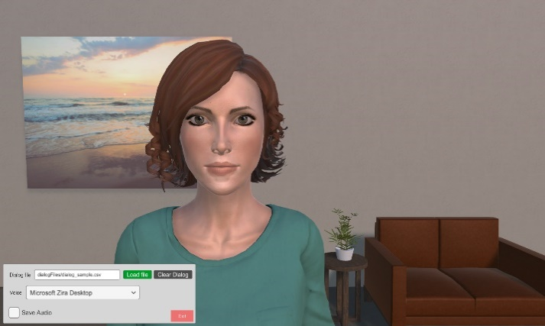
Introduction
TaCIA
You are invited to take part in a study online or at Hunter Medical Research Institute (HMRI) to help test a computer program developed by researchers at the University of Newcastle and Macquarie University. The team of researchers have developed a virtual assistant (computer character) called TaCIA, who seeks to help stroke survivors work through part of the Take Charge After Stroke program, that has been developed by researchers in New Zealand. This program is shown to help stroke patients manage their recovery.
In the study, you will:
- provide some information about yourself in a short survey.
- interact with TaCIA, answering her questions by selecting the options that best suit yourself from a menu of responses, and;
- provide feedback about your experience of interacting with TaCIA.
Please read the information below carefully.
Ask questions about anything that you don’t understand or want to know more about.
The Principal Investigator for this project is Dr Heidi Janssen.

Where is the research being done?
You are welcome to complete the study online using the below weblink. https://mquni.au1.qualtrics.com/jfe/form/SV_a5WAtmAXtgVTiho
This weblink will to take you directly to the computer assistant TaCIA website to evaluate the computer character TaCIA, with or without support. If you are wanting support to evaluate TaCIA when using this weblink, help can be provided by a member of your family, a friend or carer.
If you prefer, you can complete your session at Hunter Medical Research Institute (HMRI). Please contact Dr Heidi Janssen on 0411 114 995 or email Dr Heidi Janssen at Heidi.Janssen@health.nsw.gov.au to arrange a time convenient to you.

Who can participate in the research?
People aged 18 years or over who have had a stroke within the last five years and are living in the community.

What choice do you have?
Participation in this study is entirely up to you. If you do take part, you can leave at any time without having to give a reason. Whether or not you take part, your decision will not disadvantage you in any way.

What would you be asked to do if you agree to take part?
If you agree to take part in this study, you will be asked to complete the study on a personal computer or laptop device. Or you can request to complete your session at the Hunter Medical Research Institute. Carers or partners are welcome to attend.
The study has been designed so that you can complete the study and interact with TaCIA by yourself with the instructions provided. You can have your carer or partner help you complete the study. Using the weblink you will sign the Participant Consent Form, complete some questions, before and after using TaCIA. These questions will collect information about you (e.g. your age), how the stroke has affected you, understand your motivation levels, your prior experiences with similar technology and your feedback and experience about your interaction with TaCIA.

What do you have to do to test TaCIA?
Use a computer to:
- read and respond to questionaries and interact with TaCIA,
- answer a survey about yourself including age, how the stroke has affected you, your motivation etc,
- interact with TaCIA, from the beginning to end, and then
- answer a second survey to understand your experience of interacting with TaCIA.
What is the amount of time you would have to commit with the study?
The whole session will take about 1 hour and 30 minutes, with as many breaks as you need.

What are the risks and benefits of taking part?
There are no known risks related to participation in this research project. It may be inconvenient to travel to and spend time at the session, if you choose to complete the study at HMRI.
This research is unlikely to directly benefit you at this stage. We hope this project will improve programs for people who have had a stroke and may help other stroke survivors to decrease their risk of more strokes.
You will be able to receive the results of the study by ticking a box in the online questionnaire and stating your email or postal address.

Will the study cost you anything?
You will not be paid for your participation in this study. You will need to provide your own transport to and from HMRI if attending there. Parking will be provided.

What is the information you would provide?
- information about yourself (e.g. age) and how your stroke has affected you
- information given to TaCIA during the virtual session, and
- what you thought about interacting with TaCIA.

How will your privacy be protected?
All the information collected from you for the study will be treated confidentially (all personal details from information collected will be removed). The study results may be presented at conferences or in a scientific publication, but individual participants will not be able to be identified unless they provide written consent for this to take place.
Your personal information will be accessed, used and stored in accordance with Commonwealth Privacy Laws and the NSW Health Records and Information Privacy Act 2002. If you decide to cease participation in the study, you have to option of requesting all the information already collected from you to be deleted. Once you advise the team of your wish to cease participation you will not be contacted for any further information.
If you decide to pull out of the study, the information already collected from you will be deleted. If you pull out, we will not contact you for further information.
All information collected will be kept at Hunter Medical Research Institute, stored on a password-protected file or in a secure filing cabinet. All information will be held for a minimum of 7 years and destroyed prior to disposal to make sure it remains confidential.

Further Information
If you have any questions or would like more information concerning this project, you can contact us on 0411 114 995 or email Dr Heidi Janssen at Heidi.Janssen@health.nsw.gov.au.
Researchers involved in this research project are:
Dr Heidi Janssen – Conjoint Lecturer, University of Newcastle, Hunter Medical Research Institute,  Heidi.Janssen@newcastle.edu.au | Professor Michael Nilsson – University of Newcastle.  Michael.Nilsson@newcastle.edu.au
Professor Deborah Richards – Macquarie University.  Deborah.Richards@mq.edu.au | Ms Meredith Porte – Macquarie University.
Mr Ray Gray – Stroke Survivor | Mr Andrew Stopps – Stroke Survivor
Miss Laura Dowling – University of Newcastle

This information statement is for you to keep.
Thank you for considering the invitation to take part.
Yours sincerely,
Dr Heidi Janssen
Principal Investigator

Ethics:
This research has been approved by the Hunter New England Human Research Ethics Committee of Hunter New England Local Health District, Reference 2021/ETH00604.
Governance:
The conduct of this research has been authorised by the Hunter New England Local Health District to be conducted at the John Hunter Hospital site.
Complaints about this research:
Should you have concerns about your rights as a participant in this research, or you have a complaint about the manner in which the research is conducted, it may be given to the researcher, or, if an independent person is preferred, please contact the HNE Research Office, Hunter New England Local Health District, Level 4 West, HMRI, Lot 1 Kookaburra Circuit, New Lambton Heights NSW 2305. Telephone: 02 4921 4140. Email: HNELHD-ResearchOffice@health.nsw.gov.au and quote the reference number: 2021/ETH00604.

