Participant Information Statement
People with Aphasia and Artificial Intelligence

Title of the project
People With Aphasia and Artificial Intelligence
Lived experiences, current use, and imagined futures

Who is doing the research?
This research is run by La Trobe University.

The research team includes:
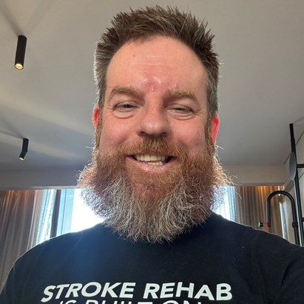
- Dr Matthew Berryman (he/him), a survivor of stroke with experience of communication difficulties after stroke.
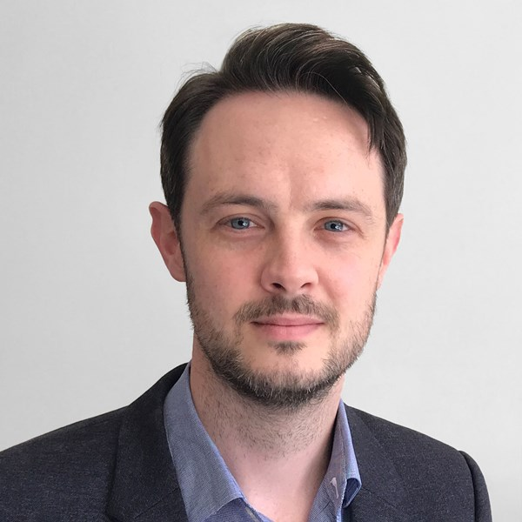
- Dr John Pierce (he/him), a speech pathologist and aphasia researcher

- A/Prof Annie Hill (she/her), a speech pathologist and aphasia researcher
Ethics approval
✔ This study has ethics approval from the La Trobe University Human Research Ethics Committee.
Ethics number: TBC

What is this study about?

Many people use technology every day.
Some technology uses artificial intelligence (AI).
AI can:
- help write or change words ✍️
- help understand speech 👂
- help with pictures or images 🖼️
- help answer questions ❓
Examples of AI include:
- assistants on your phone
- apps that help with writing or reading
- tools that explain things in simpler words
Some People With Aphasia already use AI.
But researchers do not know:
- what you are already using 📱
- what helps ✔
- what does not help ❌
- what you would like in the future 🔮
You do not need to know about AI to take part. We just want to know what you think about AI.
It’s important that people with aphasia have a say in AI!

We want to hear from you.
Why is this study important?
Most research:
- is done about people with aphasia
- is not done with people with aphasia
We want to:
- hear your voice
- learn what matters to you
- help guide future AI design

Do I have to take part?
❌ You don’t have to take part.
✔ Taking part is your choice.
You can:
- say no 👎
- say yes 👍
- stop at any time 🛑
Your choice will not affect:
- your health care
- your services
- your relationship with La Trobe University

Am I the right person for this study?
You can take part if you:
✔ have aphasia from a stroke
✔ are 18 years or older
✔ can give consent
(with or without support of family, friends or a carer)
✔ can hear and see well enough to take part
You cannot take part if you:
✖ have a different neurological condition not related to stroke
✖ Don’t speak English or can’t give consent

What will I need to do?

There are two parts to this research.
1. Screening
A short conversation to make sure you are a suitable fit.
This will be by phone, suitable video call platform or email.
If you are suitable, you will sign or agree to the consent form.
2. Online Interview
You will be interviewed by a researcher on a video call platform.

The researcher (Matthew) is a stroke survivor and who works with computers.
If you need, the interviewer can:
- use short sentences
- go slowly
- use pictures or examples
You can answer:
- by talking 💬
- by pointing 👆
- by writing ✍
- by drawing ✏️
The interview takes 60–90 minutes (1 – 1½ hours)
We will give you breaks ☕️🚽

What will we talk about?
We will ask about:
- technology you use now
- what helps or does not help
- problems or barriers
- ideas for the future 🔮
You do not need to prepare.
There are no right or wrong answers.

Will the interview be recorded?
🎥 We will record the interview.
Recording helps us:
- remember what was said
- understand communication clearly
Only the research team will see the recordings
Recordings are not shared publicly 🔒

What are the benefits?
You might:
- enjoy sharing your experience
- feel heard
- help improve future technology
But we cannot promise a benefit.

What are the risks?
Some people may:
- feel tired
- feel frustrated
- feel emotional
You can:
- take breaks ☕️
- stop at any time 🛑
Support will be provided.

What if I get upset or distressed?
If the researcher notices that you are upset or distressed, they may talk with you about what might help.
You can choose what happens next.
The researcher may offer these options:
- You can talk with your GP or another health professional.
- If you agree, the researcher can contact a trusted family member or friend for you.
- The researcher can give you information about support services, such as:
  - StrokeLine: 1800 787 653
  - Lifeline: 13 11 14
  - Beyond Blue: 1300 22 4636 or beyondblue.org.au
  - Suicide Call Back Service: 1300 659 467

You do not have to use any of these options.
You do not have to accept any referrals.
Your choices will always be respected.

Will I be paid?
✔ Yes, you will be paid for your time
✔ You will receive a Prezzee gift card for $50. This may be exchanged for Woolworths, Coles, Amazon and a variety of other retail gift cards.

What happens to my information?
Your information is confidential 🔏.
Your name will be removed.
Data is stored securely 🔒.
Only the research team can access it.
We won’t use your name in the results.
Data is kept for 7 years then deleted.

Will I hear about the results?
✔ Yes, you will hear about the results.
You can ask for:
- a plain-language summary
- updates about the study

What if I change my mind?
You can:
- stop at any time 🛑
- withdraw without giving a reason
We will explain what data can be removed.

Who can I contact?
Researcher:
Dr John Pierce
Phone: 03 9479 6096
Email: j.pierce@latrobe.edu.au

Complaints or concerns?
If you have concerns, contact:
Senior Research Ethics Officer
La Trobe University
📞 03 9479 1443
✉ humanethics@latrobe.edu.au
Quote ethics number: TBC

Consent Form

Consent to take part
I have:
- read this information
- had it explained to me
- asked questions
✔ I agree to take part in this research
Name: ______________________
Signature: __________________
Date: ______________________

Researcher signature
I have explained this study in an aphasia-friendly way.
Name: ______________________
Signature: __________________
Date: ______________________

Withdrawal Form
I wish to withdraw from the study:
People With Aphasia and Artificial Intelligence
Name: ______________________
Signature: __________________
Date: ______________________

