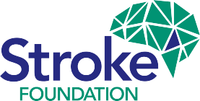
Annual Review 2022
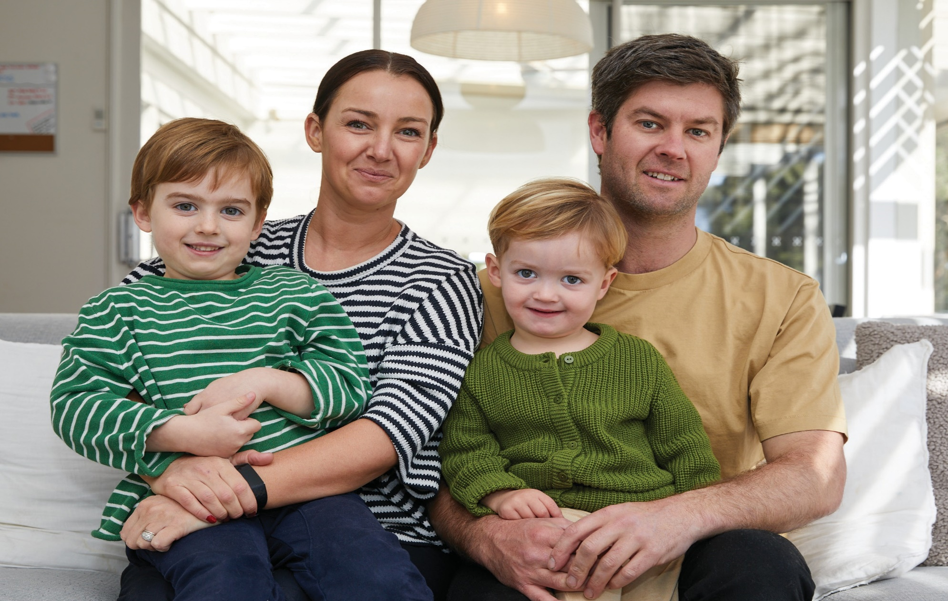

Cover image: Tahnee Haynes, survivor of stroke, with her family.

strokefoundation.org.au
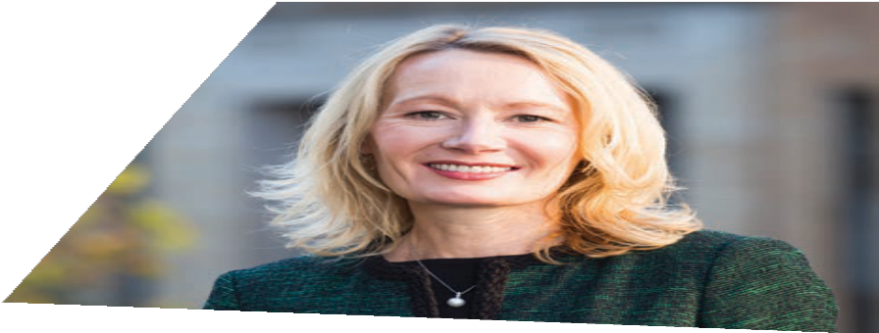

Chief Executive Officer’s message

We began 2022 under the continued cloud of the COVID-19 pandemic but with a renewed determination to increase impact across our three mission pillars – prevention, treatment, and recovery. Stroke Strategy 2024 – Empowering, Supporting, Connecting was launched and supported by a bold investment in our mission activities with additional resources in prevention, clinical education, and recovery programs.
As we slowly emerged from behind our facemasks and began reengaging face to face, our inspiring StrokeSafe ambassadors went back into community centres and corporate offices.
Their role in spreading vital knowledge about stroke prevention and the F.A.S.T. (Face, Arms, Speech, Time) message about the signs of stroke, and the need to take swift action
is invaluable.
Meetings with our clinical colleagues gave us a confronting insight into the impact of the
pandemic, particularly in rehabilitation services, with in-patient capacity slashed and survivors discharged with little or no follow-up. Armed with this knowledge, we developed a Stroke Navigator proposal which, together with a national F.A.S.T. campaign, became the central platform for our advocacy work and engagement throughout the year.
Internally, the year saw us adapt to a new hybrid way of working. This enabled our people to work

2

Stroke Foundation
flexibly while remaining deeply connected to our mission and to each other. We believe that this move to flexible working arrangements will also enable more people recovering from
stroke to actively return to the workplace. Stroke Foundation will continue to champion this model. The positive culture we have built together at Stroke Foundation was recognised in 2022 with the Best Workplace and Change Champion awards from The Voice Project.
These awards celebrated our engaged workforce, and our ability to continuously adapt and improve to advance our mission. Stroke Foundation is made up of a team of dedicated, hard-working, compassionate people, most of whom have personal connections to stroke, and all of whom will go the extra mile, every time, to improve the lives of those in our wider community.
May saw the return of our annual Stroke Awards event, held in person after a two-year pandemic- related hiatus. This was a very special occasion and a wonderful opportunity to celebrate and recognise the inspiring achievements of our community members from all walks of life. The image of our two childhood stroke champions, Dee Banks and Kylie Facer, receiving the President’s Achievement Award is something
I will always treasure.
Despite several false starts and rescheduled dates, Team Stroke finally came together in October to empower, support, and connect in person.

Over 100 employees, Board and committee members, gathered over two days in Melbourne with inspiring sessions from our young stroke project team, childhood stroke working group, and the researchers driving the next advances in stroke recovery.
It was fitting that we used this ‘reunion’ to launch our inaugural Reflect Reconciliation Action Plan which will ensure our workplace, programs and services are culturally safe, welcoming, and inclusive for Aboriginal and Torres Strait Islander peoples. We know First Nations people are more likely to have a stroke, and to have that at a much earlier stage in life. To truly tackle the inequality these communities face, we must be guided by those we are trying to help, and I am proud to have commenced our reconciliation journey at Stroke Foundation.
On a personal note, 2022 was my last year at the helm of Stroke Foundation. My seven years in the role as Chief Executive has been a privilege and an honour, and I will watch with excitement as
my successor takes this “small-but-mighty” organisation on to even greater heights.
Sharon McGowan Chief Executive Officer Stroke Foundation

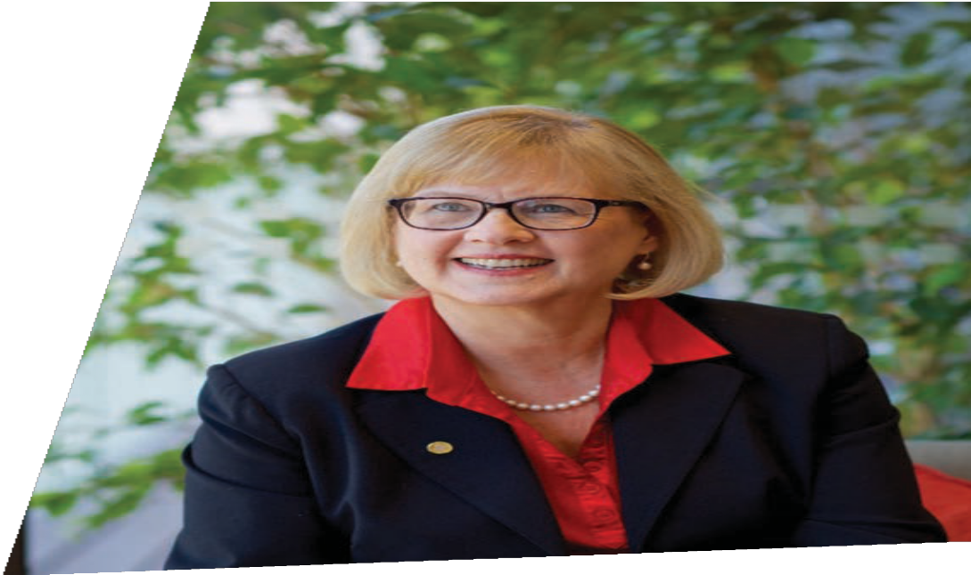

President’s message

In 2022 we embarked on our new Stroke Strategy 2024 – Empowering, Supporting, Connecting. This strategic plan has enabled us to refine and refocus our work to ensure that our core mission is always front of mind.
Our mission – to prevent stroke, improve access to treatment, and enable people to recover well – anchors our efforts. To achieve our mission, we know that we must empower, support, and
connect our community of survivors, researchers, clinicians, and families. Indeed, it is the power
of our community that allows us to achieve all that we do.
My fellow Board members and I are heartened to constantly see this vital work in action here at Stroke Foundation, through our clinical connections and programs, and through the
team’s community support and advocacy efforts.
The impact of our collective efforts for the stroke community was clear at the 2022 Stroke Awards, the first to be held in person since the beginning of the pandemic. This celebration and recognition of survivors of stroke, our volunteers, fundraisers, and donors, was a truly inspiring occasion.
Hearing the personal stories of survivors of stroke confirms the importance of our work and inspires us to do all we can to meet our goals.
Our donors, corporate supporters, and generous philanthropists fund most the organisation’s work, enabling ongoing support for other survivors. I wish to extend my sincere thanks
to everyone who contributed throughout 2022. We are grateful for the gifts you give.
I also want to take this opportunity to thank our outgoing Chief Executive, Sharon McGowan, who has led this organisation with fierce determination for seven years. Her passion, tireless drive, and dedicated commitment to Stroke Foundation’s mission has been outstanding, and the community is all the richer for her contribution.
The Board embarked upon a search for our next Chief Executive Officer, confident that we are well positioned to build on Sharon’s achievements.
We look forward to your ongoing support as we continue to deliver on our strategic focus, knowing 2023 will be a year of energetic investment in our purpose.

Emeritus Professor Linda Kristjanson AO
President
Stroke Foundation

I wish to extend my sincere thanks to everyone who contributed throughout 2022. We are grateful for the gifts you give.

3
Stroke Foundation

Stroke Strategy 2024 – Empowering, Supporting,
Connecting Our Mission Pillars

Our Stroke Strategy 2024 came into effect on 1 January 2022, having been developed in collaboration with our community, and endorsed by our Board.
Save lives
We will help
93%
of acute services and
86%
of rehab stroke service providers meet best practice requirements
Enhance recovery
We will connect
85%
of survivors and families with
appropriate support services
Prevent stroke
We will ensure
65%
of adult Australians have the knowledge and support to reduce their risk of preventable stroke
Our vision and mission remains the same as our previous strategic plan, in that we will
continue to strive for a world free from disability and suffering caused by stroke. This is a lofty goal, but one we will continue to work towards through our targeted programs and projects.

Our mission will be achieved through our three mission pillars; prevent stroke, save lives, and enhance recovery.

Stroke Foundation

4

Guiding Principles

Empowering, Supporting, Connecting

These goals are supported by three enabling pillars that support Team Stroke to increase our capability and performance, increase our research investment, and grow our profile and funding.

Improve our people capability and performance

Align our research for greatest impact

Grow our profile and funding for mission activities
We know that the trust of our community is built on evidence, so by investing in research we can find the next ‘game changer’ in stroke prevention, treatment, and recovery. We choose to be brave in our approach because having the courage to innovate enables us to truly make an impact.
The purpose of our strategy is clear; its success will mean we are Empowering, Supporting, and Connecting our community.

Together we can change the state of stroke in Australia for generations to come.

Voice of lived experience

Inclusive

Always improving

Collaborative

Evidence- based

National

Stroke Foundation 5

Prevent stroke

We empower a greater proportion of adult Australians to recognise the risks of stroke which can be changed, and in doing so increase their chances of preventing stroke.

Goal
By 2024 65% of
adult Australians will recognise the stroke risks that they can change

6 Stroke Foundation

Prevention
Stroke Foundation is committed to empowering more Australians to recognise the risks of stroke which can be changed, and in doing so increase their chances of preventing stroke. Specifically, our goal is to help a greater proportion of the community recognise the stroke risks that they can change.
Through this pillar of our strategy, we will encourage and support Australian Federal, State, and Territory governments to invest in evidence-based approaches to reduce the number of preventable strokes in the community. Collectively we aim to encourage all Australians to live healthier lives which will result in
a reduced number of strokes.

Stroke Prevention Advisory Committee
The Stroke Prevention Advisory Committee provided expert advice on several policy submissions to Government consultations, as well as critical input into the development of Stroke Foundation resources. This included position statements on stroke prevention, high blood pressure and stroke, and also smoking and stroke, which help to shape Stroke Foundation’s position on key health policy areas of importance to the Australian stroke community.

Living Well After Stroke
Living Well After Stroke is a group-based health promotion program designed to provide survivors of stroke with a toolkit of skills and strategies for making positive, healthy changes that can reduce the chance of another stroke.
In 2022, the Living Well After Stroke program and workbook, were developed by the team.
It was reviewed by people with lived experience of stroke and other relevant experts – and then piloted by a small group of participants.
A peer-reviewed protocol of the Living Well After Stroke intervention was published in BMJ Open and presented at the Smart Strokes 2022 conference in Sydney.
By the end of 2022, Living Well After Stroke successfully launched in Queensland, and two groups of participants had completed the eight-week program with recruitment ongoing.

Stroke Foundation is committed to empowering more Australians to recognise the risks of stroke which can be changed, and in doing so increase their chances of preventing stroke.

Australia’s Biggest Blood Pressure Check (ABBPC)
393 StrokeSafe talks
reached
12,027
people
49 Stroke and Recovery Webinars reached more than
4,600
people
The ABBPC campaign in May raised awareness of the link between high blood pressure and stroke; empowering Australians to know their stroke risk and understand how to manage it, by getting a health check in a pharmacy or at the doctor. This campaign coincides with World Hypertension Day each year. The 2022 publicity campaign generated media across television, radio, print and online channels, with news stories available to 500,000 people.

StrokeSafe Speaker Program
The StrokeSafe Speaker Program grew by
31 per cent in 2022, delivering 393 presentations to community groups, events, and workplaces. This saw us reach more than 12,000 Australians with lifesaving F.A.S.T. (Face, Arms, Speech, and Time) signs of stroke awareness and stroke prevention messages.

Has their FACE drooped? Can they lift both ARMS?
Is their SPEECH slurred and do they understand you? Call 000, TIME is critical.
The program trained, through a mix of online and face to face, two culturally and linguistically diverse (CALD) speakers of Mandarin and Vietnamese, and two regional speakers from Queensland towns Redridge and Taranganba. Around 36 per cent of talks were conducted within regional and CALD populations including six per cent in regional Federal F.A.S.T. electorates and five per cent in Federal F.A.S.T. priority languages.
Thanks to the generous support of Erica Foundation, Annie Danks Trust and The William Angliss Charitable Fund, Stroke Foundation was able to facilitate the rollout of much needed volunteer equipment and promotion in Victoria.

6,843
people completed the online blood pressure awareness quiz

My health for life
The My health for life program helps Queenslanders to understand their risk of developing a chronic condition including Type 2 diabetes, heart disease and stroke.
It then supports those at high risk with a free six-session healthy lifestyle program. By the end of 2022, more than 281,200 Queenslanders
completed a My health for life health check, and over 16,700 completed the program in full. A new self-paced digital program offering was also introduced to support moderate risk individuals.

Stroke Foundation 7

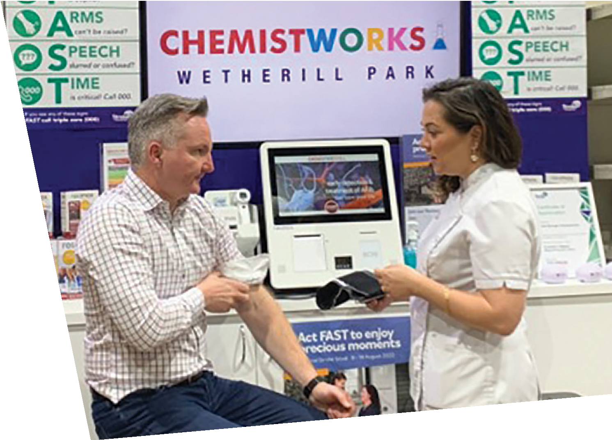
Prevent stroke case studies

Battling High Blood Pressure
This year, our prevention message gained strong support from government and industry with Federal MP, Hon Chris Bowen, and the Pharmacy Guild of Australia joining forces to conduct blood pressure checks. The Australia’s Biggest Blood Pressure Check campaign
put prevention in the spotlight for another year, and more than 1,600 Australians put their best foot forward to reduce their stroke risk by getting active for Stride4Stroke 2022. Stroke Foundation has also joined forces with other health organisations to form Australia’s
first National Hypertension Taskforce, as a way of tackling the biggest modifiable risk factor of stroke.

The Taskforce’s goal is to more than double Australia’s blood pressure control rates from 32% to 70% by 2030.

Tahnee Haynes is a proud advocate for Stroke Foundation, and wants more people to know the risks and signs of stroke. In October she shared her stroke story with Victorian Premier, Hon Daniel Andrews, and Minister for Medical Research, Hon Jaala Pulford, at a roundtable on self-advocacy in the health system.

8 Stroke Foundation

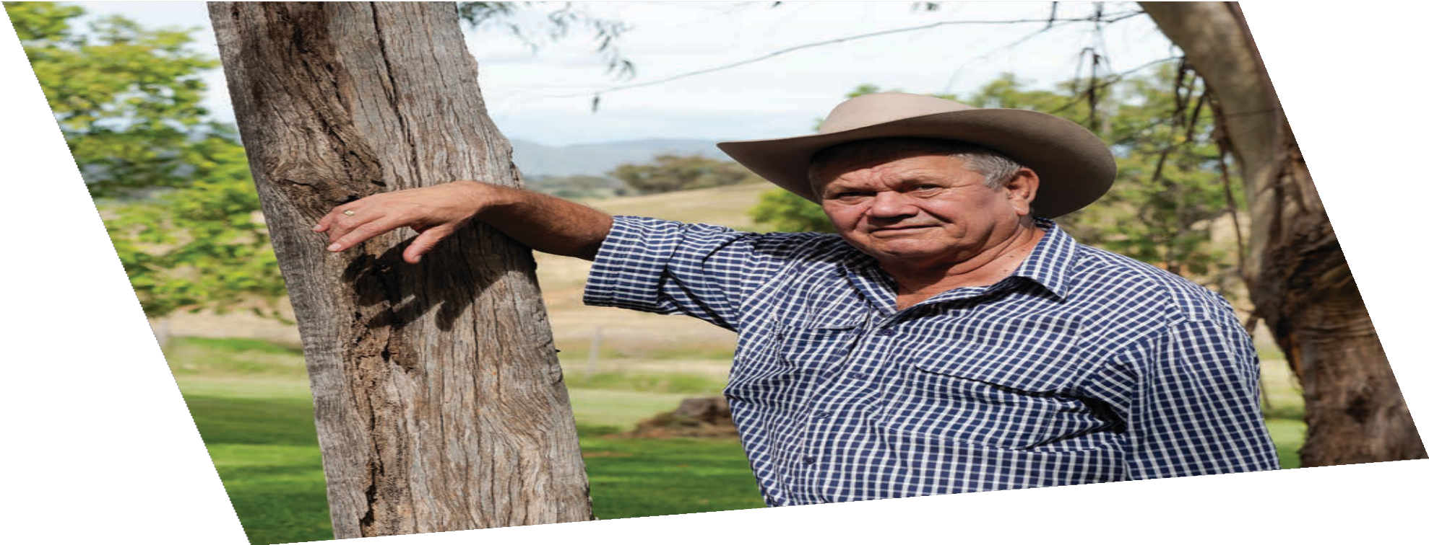

Joe Miller
Tamworth’s Joe Miller, a proud Kooma/Bidjara man, was in his early 50s when he had his first stroke. He tells the story of trying to eat a pie and finding his arms not working properly, making the experience messy and confusing. He says he knew the signs of stroke and recognised that the trouble with his arms was a huge problem – his workmates called an ambulance and Joe got to hospital fast enough to have the best chance of treatment.
Now, after having five strokes in two years, Joe has established himself as a leader in stroke prevention. He works hard to educate his community on stroke awareness and risk factors through health talks, and his work hasn’t gone unnoticed. In March this year, Joe received the Senior Volunteer of the Year Award for the New England/Northern Inland area of New South Wales.
Joe’s message is clear – he encourages people to stop smoking, to keep their stress levels down, and to drink in moderation. Importantly, he says, help is always available, and people can get the support they need to change their own risk levels.

Help is always available, and people can get the support they need to change their own risk levels.

9
Stroke Foundation

Save lives

We support hospitals and healthcare providers across Australia to strengthen their capabilities in stroke care and rehabilitation services.

Goal
By 2024 93% of
acute services and 86% of rehabilitation services will meet best practice

Treatment
To ensure all Australians have access to evidence-based stroke treatment, we work
with the stroke health professional and research community to define what treatment should be, via the world-leading Clinical Guidelines for Stroke Management. Collectively we work to ensure evidence is used in clinical practice.
We do this by monitoring hospital stroke care through the National Stroke Audit, continuing our support of the Australian Stroke Clinical Registry (AuSCR), and promoting use of it’s data to drive quality improvement. We partner with state governments in Queensland and Tasmania to deliver quality improvement activities.
We also continue to support health professional education via our online learning modules, freely available on InformMe.org.au, and our national webinar program.

Australian Stroke Alliance
Stroke Foundation partners with The Australian Stroke Alliance in a $40m research program, aiming to revolutionise stroke care by taking the emergency department to the patient.
The Alliance will lead consumer engagement and contribute to clinical education in preparation for the introduction of lightweight
brain scanners in road and air stroke ambulances.

Clinical guidelines
The Stroke Clinical Guidelines moved to ‘business as usual’ following the three-year funding to develop and test the process.
Ten topics were updated and approved in August and December. Over 5,000 new studies were reviewed during the year with approximately 10 per cent considered for inclusion by over 140 clinical experts involved.
Three articles were published in various medical journals on the Living Guidelines experience.

requirements Over 5,000 new studies were reviewed with approximately 10% considered for inclusion
by over 140 clinical experts involved.

10 Stroke Foundation

Mobile Stroke Unit (Stroke Ambulance)
In 2022, we marked the fifth anniversary of Melbourne’s Mobile Stroke Unit (MSU). The MSU was dispatched 1,500 times, and attended 492 patients across Melbourne, rendezvousing with incoming regional paramedics. Stroke Foundation was an integral funding partner in the establishment of this world-class service, which has now serviced 2,735 patients over its five years of operation.

Telestroke
We worked closely with health departments across Australia in the roll out of Telestroke, which has proven beneficial in improving treatment times, and access across various regional and rural Australian regions. This was the first year of our expanded Telestroke service in Western Australia and we, alongside our colleagues at the Stroke Society of Australasia, advocated heavily and will continue to do so, for a Telestroke service in Queensland.

Audits
In response to the external review of the audits in late 2021, we spent 2022 reviewing

The Mobile Stroke Ambulance celebrated its 5th year in operation and was dispatched
1,500 times
and refining the audits which included a mapping of the current indicators to the Living Stroke Guideline recommendations, a survey of hospital coordinators and leading experts, and discussion with our Clinical Council. During this time, and
as a response to the impact of COVID-19, we paused The Rehabilitation Audit. We also worked with the Florey Institute of Neuroscience and Mental Health, and the stroke community, to identify the requirements for an updated stroke data capture tool to replace the current Australian Stroke Data Tool (AuSDaT).
Telestroke
is now available in

7

states and territories

Stroke Living Guidelines
gave clinicians access to
500
new studies

Stroke Foundation

11

Save Lives case studies

Clinical excellence accreditation project

Improving treatment outcomes for survivors of stroke is one of the key focuses for our treatment team, and this year it’s led to a new project aimed at addressing major gaps in hospital stroke care.
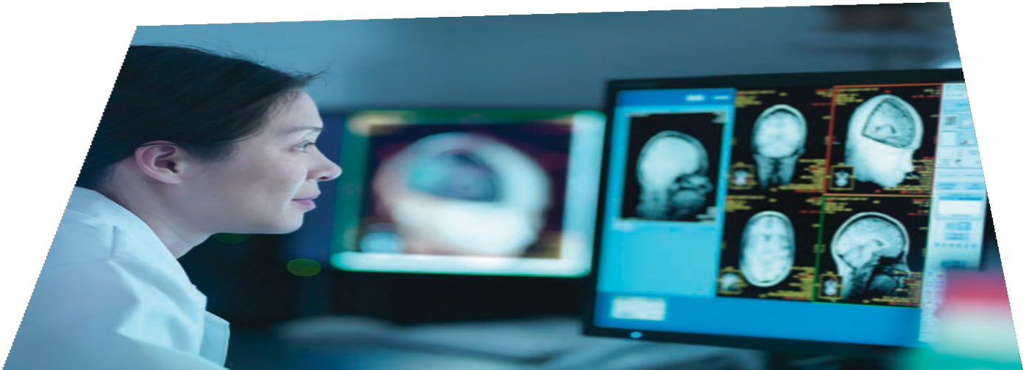
A new certification system will be established in several Australian hospitals, encouraging stroke units to reach targets and strive to improve their performance with formal recognition of certification.
It comes after the National Acute Services Audit found that not all Australian hospitals with a designated stroke unit are meeting the requirements for stroke unit care, as outlined in the Australian Stroke Services Framework and Acute Stroke Care standards. This means
some people with stroke are being provided suboptimal care which impacts their recovery.
Once launched, the Clinical Excellence Project will improve treatment for survivors of stroke across Australia and encourage a high standard of treatment across the board, ensuring survivors of stroke receive the best care possible.

Once launched, the Clinical Excellence Project will improve treatment for survivors of stroke across Australia and encourage a high standard of treatment across the board, ensuring survivors of stroke receive the best care possible.

12
Stroke Foundation

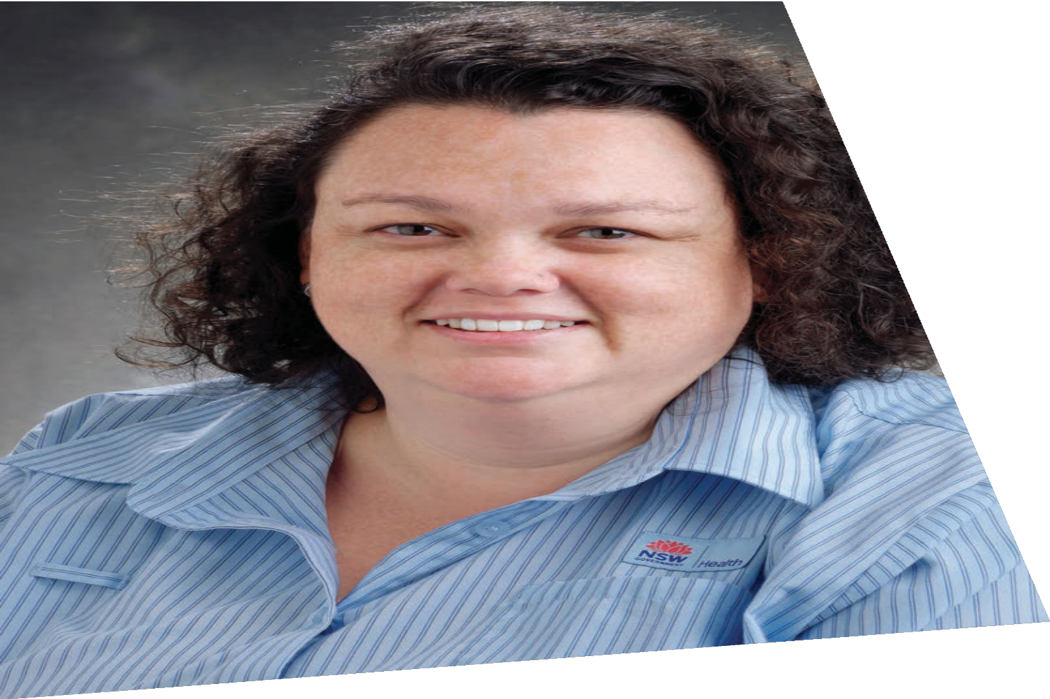

Stroke Care Champion
Every year, we shine a light on the wonderful professionals who demonstrate excellence in stroke care through the Stroke Care Champion Awards.
In 2022, the honour was given to Sydney stroke Nurse Practitioner, Kylie Tastula, who works in the stroke unit at the Royal Prince Alfred Hospital.
Kylie won the award for showing dedication to stroke services, and being a caring, thoughtful, supportive, and knowledgeable person with patients, carers, and fellow clinicians alike.
Kylie’s achievements include developing a state-wide Endovascular Clot Retrieval (ECR)
and virtual reality module for hyperacute stroke, a peer mentorship program across 23 rural sites in New South Wales, as well as being the lead nurse for the inaugural New South Wales Stroke Ambulance Model of Care development.

Kylie Tastula won the 2022 Stroke Care Champion Award.

Stroke Foundation 13

Enhance recovery

We connect with those impacted by stroke to ensure more Australians can access trustworthy information, resources, and post-stroke support.

Goal
By 2024, 85% of
Australians impacted by stroke will be offered
a connection to Stroke Foundation and can access trustworthy information, resources, and post-stroke support

14 Stroke Foundation
Information

EnableMe
Our stroke recovery website, enableme.org.au, connects survivors, families and carers to information and support, no matter where they are in Australia. In 2022, over 76,000 survivors of stroke, their families, carers, and health professionals accessed 330,000 pages of information through EnableMe.

Young Stroke Project
The Young Stroke Project was a three-year
co-designed project delivering better information for people aged 18 to 65, beginning in 2020 and ending in 2022. Over 1,000 people with lived experience have contributed to the project in some way.
A new website, young.strokefoundation.org.au, launched on 17 August, 2022. The website has been created by, and for, young survivors of stroke, their familes, carers and friends.
In 2022, the project delivered 32 videos,
18 podcasts and nine blogs. Every aspect of life after stroke was covered – from fatigue, relationships, and to being your own champion.
In 2022, 13,787 survivors of stroke, their families, carers and health professionals accessed
14,629 pages of information.
The Young Stroke Project was funded by the Australian Government Department of Social Services.

Childhood Stroke
Our first Childhood Stroke Lived Experience Advisory Group was launched in January, giving an important voice for Australians impacted by childhood stroke.
The group comprises six adults who had a stroke as a child, and six parents of young survivors. This is the first advisory group specifically formed to represent the needs of survivors of childhood stroke, their families, and carers. Its importance cannot be understated, given approximately
600 Australian children experience a stroke each year. Our work in childhood stroke is generously supported by the Barr Family Foundation.

Stroke Journey resources
The definitive guide for survivors of stroke, their families, and carers for navigating the journey from hospital to home after stroke, and beyond. My Stroke Journey is a suite of resources, with versions for Aboriginal and Torres Strait Islander people, and for parents and carers whose child has had a stroke. With generous support from donors and partners, this resource is provided freely to all hospitals. In 2022, 163 hospitals delivered 24,973 copies of My Stroke Journey.
In total, 77 per cent of Australian stroke patients received a copy of My Stroke Journey.

Support

StrokeLine
StrokeLine’s health professionals provide advice on stroke prevention, treatment, and recovery via this practical, free, and confidential service. By phone and through digital engagements,
StrokeLine provided information and support
to 2,600 survivors of stroke, their families, carers, and friends during 2022, a one per cent increase on the previous year.
StrokeLine is a highly regarded service, with
88 per cent of clients in 2022 saying they would recommend it to someone else. This is similar to 2021, indicating we deliver a consistent and positive user experience.

i-Rebound
i-Rebound is a new website designed to help survivors of stroke to reduce their risk of another stroke. i-Rebound was developed with survivors of stroke, as part of a partnership between the University of Newcastle and Stroke Foundation. i-Rebound provides an evidence-based, practical approach to eating well and moving more after stroke.
It was launched in November 2022, and in its first months more than 5,000 people accessed the site, with 24,902 individual page views, and a high engagement rate of 57 per cent.

StrokeConnect Navigator
StrokeConnect Navigator is an outreach service that builds on the services delivered by the StrokeLine team. Collectively the two services make up the StrokeConnect Navigator Program.

13,787
people have visited the Young Stroke website since it launched in August
The Navigator component provides a referral pathway for hospitals to ensure more people are connected to high quality, best practice
assessment, care coordination, stroke information, and advice via Stroke Foundation. Its intent is to have fewer people “fall into a black hole” between hospital and home, a reality we have heard consistently from the thousands of survivors who leave hospital without information or discharge plans.

Our free helpline, StrokeLine, has answered more than
2,500 calls
StrokeConnect Navigator is currently being delivered in Tasmania and the Australian Capital Territory (ACT), funded by the Tasmanian and ACT Governments, respectively.
In 2022, StrokeConnect Navigator supported 646 people in Tasmania and the ACT, to manage their recovery better.
My Stroke Journey
is being translated into

8 languages

Stroke Foundation 15

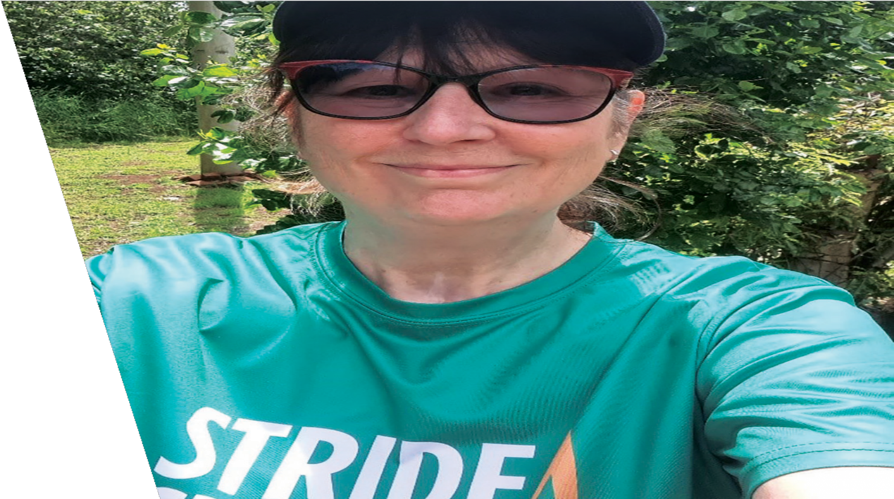
Enhance recovery case studies

Sharon Dobson
Sharon Dobson credits her stubbornness for helping her overcome and survive more than one brush with death. The Tasmanian woman was involved in a serious car crash in February 2019. The impact perforated her bowel causing serious internal bleeding, and nine mini strokes.
Otherwise known as transient ischemic attacks (TIAs), these mini strokes are temporary blood clots in the brain. They clear themselves, but one in three people go on to have larger strokes.
One week later, Sharon was undergoing surgery when she experienced the major, life-altering 10th stroke which permanently impaired her lefthand side. She says the experience was extremely traumatic for her family who were located more than an hour and a half away.
Almost three years later, Sharon continues to visit rehab three times a week and still
experiences numbness on her left-hand side.

Sharon participated in Stride4Stroke in 2022, and is passionate about raising
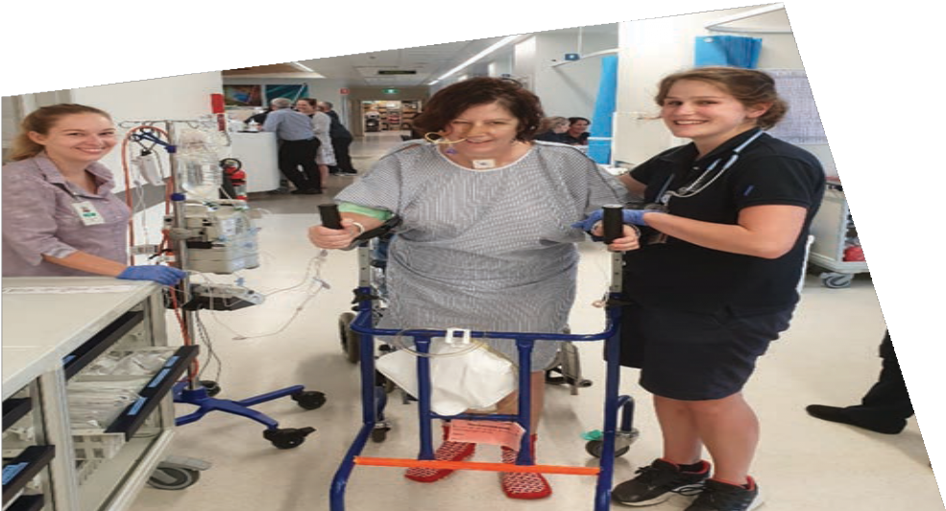
awareness for other survivors of stroke.

16 Stroke Foundation

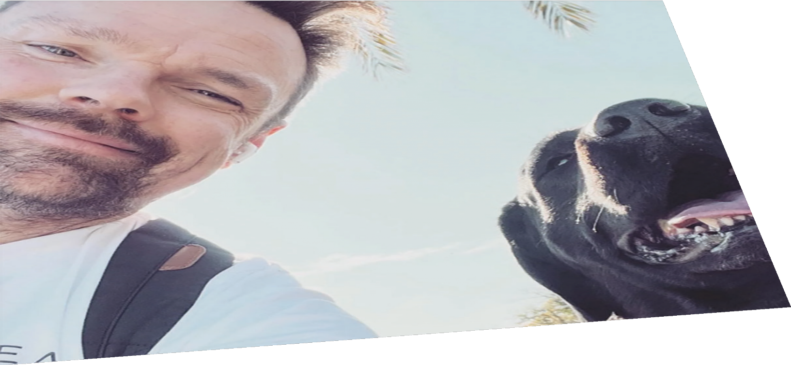

Kris Vanston
The pandemic was challenging for all Australians. But it was particularly tough for Kris Vanston.
The Melbourne man was undergoing routine surgery when an artery in his neck burst, and he experienced a huge stroke.
Health professionals warned his family his future was bleak. They were told he may never recover and should be put into full time residential care. With the support of his four-legged best friend Beau, Kris defied the odds. He learned how to walk and talk again with his beloved Labrador by his side every step of the way.
Kris lives with aphasia, a language and communication disorder. He started his own business and credits Beau for getting him through challenging periods. He has become a Stroke Foundation volunteer and is a valued
member of the team.
“Beau not only got me through some of my darkest days,but saved my life and continues to provide healing benefits.”

17

Stroke Foundation

Reconciliation Action Plan launch

In 2022, Stroke Foundation marked a significant achievement in the organisation’s 26-year history, with the official launch of its Reflect Reconciliation Action Plan (RAP) at the Team Stroke meeting.
The RAP marks Stroke Foundation’s formal commitment to reconciliation, and was developed in close partnership with Aboriginal and Torres Strait Islander communities. The RAP outlines a clear pathway we will take to support and maintain meaningful opportunities, and strong relationships, with First Nations peoples.
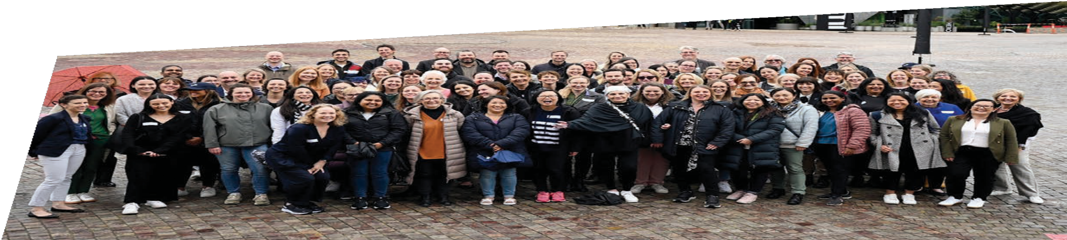
It encourages self-determination, respect and recognition, and aims to close the gap on the inequities that exist in Aboriginal and Torres Strait Islander communities. The RAP
is a significant way Stroke Foundation can play its part in Australia’s reconciliation journey and this work is a key area of focus of the Foundation’s Strategic Plan.

A standout feature of the RAP is the beautiful artwork that adorns the pages of the document. It is the work of New South Wales artist, Carissa Paglino, a descendant of the Wanaruah nation who has a personal connection with stroke.
Carissa’s artwork depicts themes of support, community, leadership, and courage.
In addition to launching the first RAP, Stroke Foundation has committed to establishing and maintaining relationships with Aboriginal and Torres Strait Islander stakeholders and organisations. As part of this commitment,
we partnered with a First Nations organisation to develop and deliver cultural awareness training to all employees and volunteers.

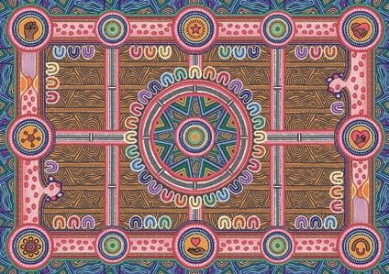
Artwork by Carissa Paglino

18
Stroke Foundation

Highlighting our Impact

Teaching more Australians the
F.A.S.T. signs of stroke
The F.A.S.T. message highlights the three most common ways to recognise a stroke (Face, Arms, and Speech), and reminds us that Time is critical when seeking treatment, as stroke is always a medical emergency. Stroke Foundation shares this message widely to encourages all Australians to learn it and share it with others.

Annual F.A.S.T. Awareness Survey
Stroke Foundation’s 2022 population health survey found just 33 per cent of Australians recognised two or more signs of stroke, which is a three per cent improvement on the year
before. However, the survey showed 38 per cent of Australians still cannot name any of the signs of stroke, and that figure was even higher in metropolitan Sydney and Adelaide, at 47 per cent.

Federal Government grant for F.A.S.T. education
Now in its third year, the Federal Government- funded F.A.S.T. project ($800,000 over four years) reached over three million Australians with the signs of stroke awareness messages. A multi- channel advertising campaign targeted regional and culturally and linguistically diverse (CALD) communities in the 40+ age bracket.
Resources which feature the F.A.S.T. message (bookmarks, wallet cards, and magnets), as well as StrokeSafe speaker presentation slides and speaking notes, were also translated into eight languages for the project.

Has their FACE drooped? Can they lift both ARMS?
Is their SPEECH slurred and do they understand you? Call 000, TIME is critical.

Government funders
With the support of the New South Wales, Australian Capital Territory, Western Australian, Tasmanian and Federal Governments, our F.A.S.T. community education continued to expand into regional and culturally and linguistically diverse communities across the country. We appreciate the support from these Governments, as we have seen significant uplift in awareness in these states and territories.

Stroke Foundation 19

Stroke Awards

Volunteer of the Year Award
Tony Howe (TAS)

Stroke Foundation’s annual Stroke Awards acknowledges and celebrates people who contribute to the stroke community, and everyday go above and beyond to make things

2022 Winners
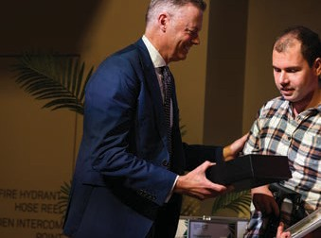
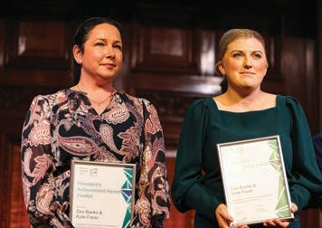
better for Australians impacted by stroke.
The 2022 Stroke Awards was an exciting event as our first face to face event for two years as the COVID-19 pandemic restricted our activities.
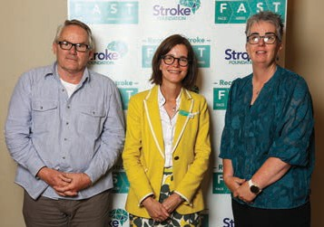

Courage Award
Tommy Quick (VIC)

Creative Award (highly commended)
Paul Blackman and Jane Cross (VIC)
We were glad to hand awards to our deserving finalists and winners.

President’s Achievement Award
Kylie Facer (NSW) and Dee Banks (VIC)
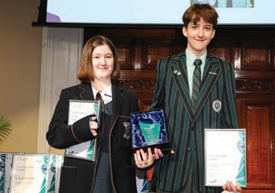
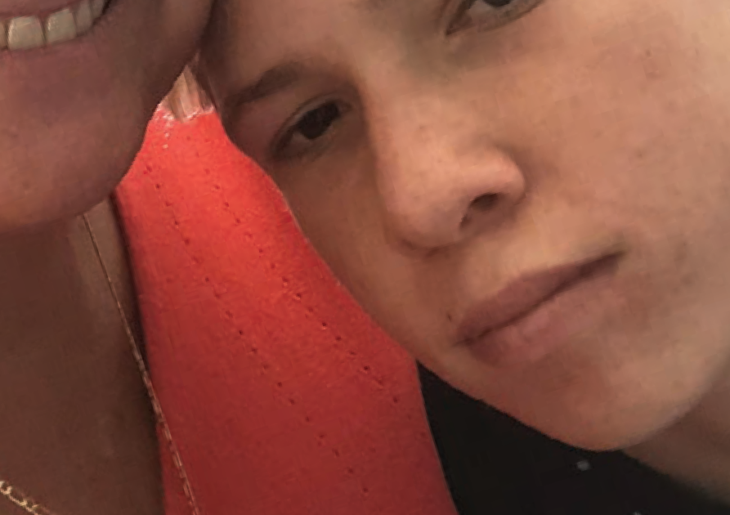

Stroke Warrior Award
Sophie and Elliot Clayton (QLD)
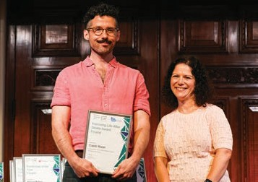

Improving Life After Stroke Award
Caleb Rixon (VIC)
Fundraiser of the Year Award
Nicola Baker (QLD)

20 Stroke Foundation

National Stroke Week 2022
The 20th annual National Stroke Week, held in August, asked Australians to think about
the Precious Moments that can be saved when timely stroke treatment leads to a good recovery. One of the highlights of the week this year was when almost 30 monuments and buildings across Australia lit up in green and blue to help spread the message.

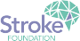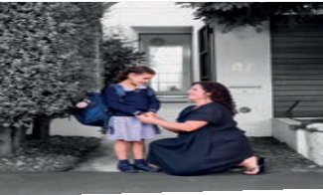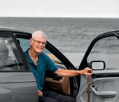
Act FAST to enjoy precious moments
National Stroke Week 8 – 14 August 2022
Learn the F.A.S.T. (Face, Arms, Speech, Time) signs of stroke to keep enjoying life’s precious moments.
MAJOR PARTNERS SUPPORTING PARTNERS
This year’s campaign was highlighted in 651 news items across Australia, featuring in newspapers, radio, print, online and TV with the opportunity to have reached almost nine million
people over the nine days of coverage.

Research
Our Stroke Strategy 2024 highlights our commitment to supporting stroke research. During 2022, the program focused on researchers and people with lived experience of stroke working together to co-design solutions.

Nancy and Vic Allen Stroke Prevention Memorial Grant (up to $100,000)
A new two-year grant was awarded to address primary prevention of stroke through effective management of stroke-specific risk factors:
- Associate Professor Caleb Ferguson, University of Wollongong ‘INFORM-AF II– A Phase 1 pilot randomised controlled trial of a digital stroke prevention education program for people living with atrial fibrillation’.

Seed Grants recipients (up to $80,000)
Four seed grants up to $80,000 were awarded to early and mid-career researchers, to explore new ideas and tackle gaps in knowledge and practice for stroke prevention, treatment, and recovery.
The 2022 grant round recipients (publicly announced in early 2023) were:
- Dr Lucette Lanyon, La Trobe University ‘Phase II investigation of the feasibility, acceptability, and preliminary efficacy of a Hub-and-Spoke, Peer-Led Community Aphasia Group program’.
- Dr Kate Scrivener, Macquarie University ‘Effectiveness of a mobility booster program (Hi-Walk) in long-term community stroke rehabilitation’.
- Dr John Pierce, La Trobe University
‘M-MAT Tele: Maximising aphasia recovery through a group telehealth intervention’.
- Dr Dawn Simpson, University of Newcastle ‘Co-design and testing of a novel ‘fatigue protectometer’ to tackle post-stroke fatigue’.

Stroke Foundation 21

Supporting Stroke Foundation

Volunteers
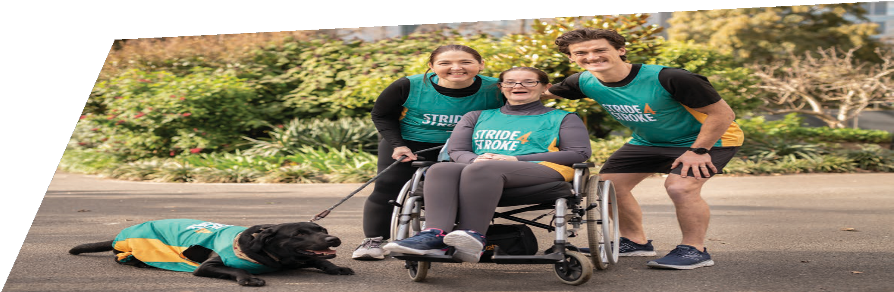
Stroke Foundation’s volunteer workforce is immensely valued. Our volunteers contributed 7,300 hours in 2022, with more than 213 volunteers working across 21 roles in various programs that includes: marketing, media and advocacy, Board, committees, and councils.
That included 1,046 hours specifically worked on our Board and our councils, 1,148 through the StrokeSafe Speaker program and 5,106 in all other areas combined.
Many of our volunteers hold close personal connections with our mission and vision, and we are grateful for their generosity and willingness to support us.

Fundraise4Stroke
Our wonderful community fundraisers took up the challenge to raise much needed funds for us.

Throughout 2022 more than 500 fundraisers raised over
$325,000 through a variety of Fundraise4Stroke and fitness events.
Stride4Stroke
Stride4Stroke is Stroke Foundation’s largest community fundraising event, where we encourage the community to get active during the month of November. In 2022, Stride4Stroke saw 1,616 individuals and 238 teams of Striders

hit the track, pool, ride a bike or undertake stroke rehabilitation, to reduce their risk of stroke, or secondary stroke. During the month Australians logged 914,568 Moving Minutes and raised
$342,202.

22 Stroke Foundation

Counterstroke Golf Classic
Played each year since 1994, a committee of dedicated volunteers annually host two golf classics in the Mornington and Bellarine Peninsulas. Both golf classic tournaments are run over three days and offer mutually exclusive competitions in women’s, men’s and mixed events.

More than

320 golfers
took part in 2022, raising almost

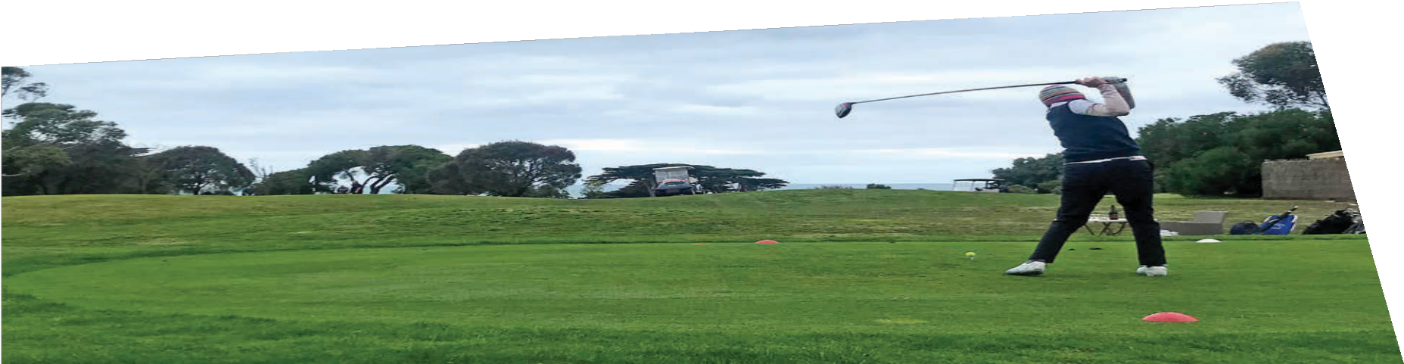
$80,000

Governance
Since incorporation in 1996, Stroke Foundation has been governed by an independent Board of Directors. The Board is supported by the expertise of leading health professionals and researchers in stroke, and is informed by survivors of stroke, carers, and their families.
Stroke Foundation’s corporate performance is overseen by the Audit, Finance, Investment and Risk Committee and the Governance and Nominations Committee. The Philanthropy Committee provides advice to achieve the organisation’s philanthropic endeavours.

Advocacy
Stroke Foundation is an apolitical organisation, meaning we will engage and partner with all Australian governments to secure funding and deliver our programs. We encourage our wider community of survivors of stroke and their own networks to share their personal stories
with their local elected Members, to highlight the benefits, and ongoing need for our services and support.

Stroke Foundation 23

Sharing our message

In the news
Stroke Foundation harnesses the power of Australia’s news media to share our message, and featured in 3,664 individual news articles, radio broadcasts, and television news bulletins, giving us the opportunity to reach 67m Australians over the 12 months.
Stroke Foundation

24

Digital performance
Stroke Foundation’s website performed strongly in 2022, recording approximately 105,000 page views per month, by 54,000 users. The most popular page was ‘Signs of stroke’, which explains the three main signs of stroke
(Face, Arms, Speech) in English, and offers links to the same material in Arabic, traditional Chinese, simplified Chinese, Greek, Hindi, Italian, Korean, and Vietnamese.

Advertising campaign reach
Throughout 2022, strokefoundation.org.au attracted over 24,000 page views per week.
Stroke Foundation relies on its donors for the funding needed to deliver its information, services, and resources. We appeal to the public using a variety of channels, so all sectors of the community understand why we need their financial support.
- To appeal to the Australian general public
for donations we used Facebook, Google Ads and Microsoft Ads.
Total Impressions: 3,862,745
- Our call for participants for Stride4Stroke went out through Facebook, Instagram, Google Ads, YouTube, Microsoft Ads and Tik Tok. Total Impressions: 4,627,142
- Encouraging people to consider our Gifts In Wills program was promoted using Facebook Ads and Google Ads. Total Impressions: 1,035,469
- Sharing the F.A.S.T. message nationally included Facebook Ads, Instagram, YouTube, and newspaper advertising.
Total Impressions: 3,579,210
- Promoting our annual Stroke Week was done through Facebook Ads, LinkedIn, and YouTube. Total Impressions: 2,551,736
- Two bespoke paid campaigns targeted Culturally and Linguistically Diverse communities in-language and the 10 electorates (Federal) where people had the highest levels of stroke risk. Using a combination of radio, print, and Facebook channels, our reach was 838,328. Total Impressions: 1.2m

Financials

On the back of a $1,033,000 surplus in 2021, the Foundation budgeted a deficit of $1,100,000 for 2022, to support delivery of the strategic plan, with a focus on mission related expenditure.
Program Support
Prevention & community awareness
Improving stroke care
Survivors of stroke support programs
Research Advocacy
Other
Total
+47.2%
+17.2%
+16.2%
+11.9%
+7.3%
+0.2%
100%

The operating result for the 2022 year was a net deficit of $3,240,000. Budgeted deficits are not anticipated to be a long-term strategy, with the Foundation intending to return to budgeted surpluses in the near future.
During the year, the Foundation continued to deal effectively with the ongoing impacts of the coronavirus COVID-19 pandemic. Despite ongoing restrictions, fundraising programs were able to maintain growth in regular giving donors, which is now the largest income stream, that provides a reliable, consistent source of ongoing revenue.
Sources
of Income:
$17.5m
Donations & Bequests Government Grants & Subsidies
Other Revenues Goods or Services Investment Income
Total
Donations & Bequests:
$13.7m
Regular Giving
Bequests Appeals & Fundraising Events & Community
Corporates, Trusts & Foundations
Total
+78.1%
+22.7%
+0.9%
+0.2%
-1.9%
100%

+47.5%
+18.5%
+25.6%
+5.5%
+2.8%
100%

25

Stroke Foundation

Those who stand beside us

board

As Australia’s only national charity dedicated to stroke, we are privileged to have many talented, passionate, and generous supporters standing alongside us. We are the trusted voice
of stroke in Australia, but without this incredible team and community, that role would be so much harder to fulfil.

We thank all those who inspire us and champion our work:
Our

President
› Emeritus Professor Linda Kristjanson AO

Vice President
› Mr Christopher Nunn

Directors
› Professor Amanda Thrift (resigned 11 Aug 2022)

  - Patrons.
  - Ambassadors.
  - Our Board.
  - Our Clinical Council.
  - Our Consumer Council members.
  - Our Audit, Finance, Investment and Risk Committee.
  - Our Governance and Nominations Committee
  - Our Research Advisory Committee.
  - Our Philanthropy Committee.
  - Our Stroke Prevention Advisory Committee.
  - Our Childhood Stroke Lived Experience Advisory Group.
  - Our Young Stroke Lived Experience Advisory Group.
  - Our Reconciliation Action Plan Working Group.
  - Governments, health services and health professionals, right across the country.
  - Our employees, our amazing volunteers, and our supporters.
  - And to all those who are personally impacted by stroke – you are our inspiration.
› Professor Bruce Campbell
We express our heartfelt thanks to you all.
› Ms Jennifer Muller PSM
› Ms Karen Vernon
› Ms Sally Bateman
› Mr Andrew Matthews (resigned 4 May 2022)
› Ms Janice Thomas
› Mr Peter Nikoletatos
› Mr Phillip Vernon (appointed 25 Jan 2022)
› Professor Coralie English (appointed 4 May 2022)
› Mr Robert Campbell (appointed 24 Aug 2022)

Company Secretary
› Mr Matthew Oakey

26
Stroke Foundation

Patrons, Ambassadors and Councils

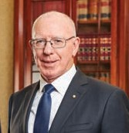
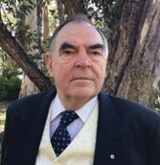
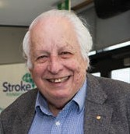
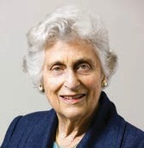
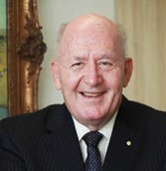
Patron-in-Chief
His Excellency General the Honourable David Hurley AC DSC (Retd)
Patron
Mr David Brownbill AM
Patron
Sir Gustav Nossal AC CBE
Patron
Lady Marigold Southey AC
Ambassador
General the Honourable Sir Peter Cosgrove
AK CVO MC (Retd)

Clinical Council
› Professor Bruce Campbell, Chair
› Dr Rohan Grimley
(retired 31 Aug 2022)
› Professor Susan Hillier
(retired 31 Aug 2022)
› Dr Claire Muller
(resigned 15 Feb 2022)
› Ms Skye Coote
› Dr Timothy Ang
› Professor Natasha Lannin, Deputy Chair
› Professor Steven Faux
› Associate Professor Seana Gall
› Associate Professor Mark Mackay
› Associate Professor Martin Jude OAM
› Dr Carlos Garcia-Esperon
(appointed 23 Feb 2022)
› Ms Annabelle Vaughan
(appointed 4 May 2022)
› Dr Helen Dewey
(appointed 3 Nov 2022)
› Dr Tamina Levy
(appointed 3 Nov 2022)

Stroke Prevention Advisory Committee
› Associate Professor Seana Gall, Chair
› Dr Siobhan Hickling
› Professor David Thomas
› Professor Mark Harris
› Professor Simone Pettigrew
› Dr Nicholas Gilson
(appointed 4 May 2022)

Consumer Council
› Ms Jennifer Muller PSM, Chair
› Ms Nadia Moffatt OAM
(retired 27 Apr 2022)
› Mr Kevin English
› Mr Tony Finneran
› Mr Tony Rolfe, Deputy Chair
› Ms Saran Chamberlain
› Ms Kim Beesley
› Ms Jasmina Behlic
› Ms Elisha Deegan
› Ms Tala Olins-Miller
(appointed 5 Apr 2022)
› Mr Robert Campbell
(appointed 4 Nov 2022)
› Dr Luckmika Perera
(appointed 1 Dec 2022)

Audit, Finance, Investment and Risk Committee
› Mr Christopher Nunn, Chair
› Mr Peter Fekete
(retired 22 Mar 2022)
› Mr Alan Lahiff
› Mr Andrew Matthews
(resigned 4 May 2022)
› Mr Narayan Prasad
› Mr Phillip Vernon, Deputy Chair (appointed 25 Jan 2022)
› Mr Peter Nikoletatos
(appointed 4 May 2022)
› Mr Robert Campbell
(appointed 4 Nov 2022)

Governance and Nominations Committee
› Ms Karen Vernon, Chair
› Ms Sally Bateman
› Professor Linda Kristjanson AO
› Mr Christopher Nunn

Research Advisory Committee
› Professor Amanda Thrift, Chair (resigned 11 Aug 2022)
› Ms Brenda Booth OAM
› Associate Professor Caleb Ferguson (retired 2 Nov 2022)
› Associate Professor Emma Power
(retired 20 May 2022)
› Professor Ian Kneebone
› Associate Professor Nadine Andrew
› Professor Mark Nelson
› Dr Eleanor Horton
Continued over page

27

Stroke Foundation

› Professor Coralie English, Chair (appointed to
Chair 12 Aug 2022)
› Associate Professor Ronil Chandra
› Dr Samantha Siyambalapitiya
› Associate Professor Monique Kilkenny (appointed 10 Aug 2022)
› Ms Saran Chamberlain
(appointed 1 Dec 2022)
› Dr Katharine Brown
(appointed 1 Dec 2022)

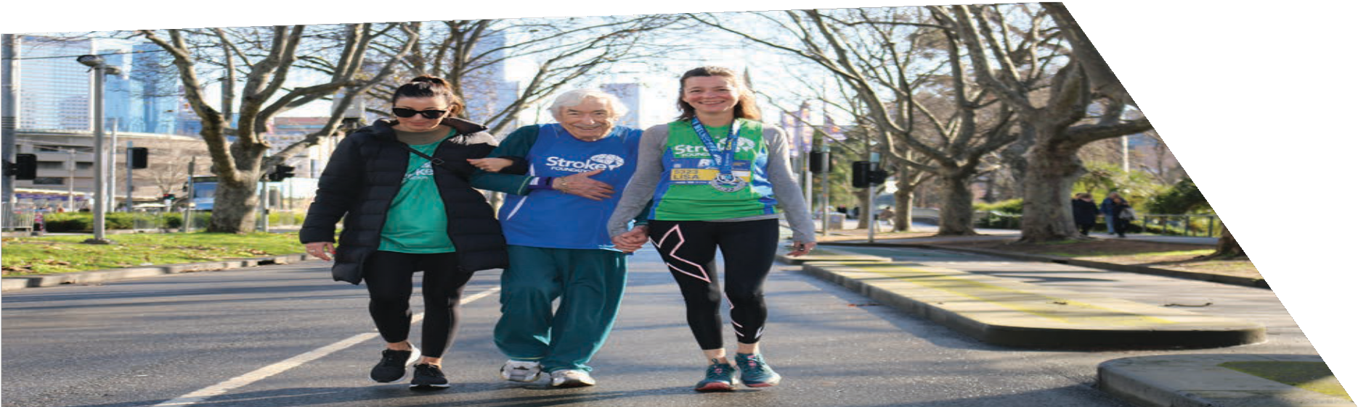
Philanthropy Committee

28
Stroke Foundation
› Mr Andrew Matthews, Chair (resigned 4 May 2022)
› Professor Linda Kristjanson AO
› Ms Janice Thomas
› Mr Phillip Vernon
(appointed 5 May 2022)
› Mr Tony Hume
(appointed 10 Aug 2022)
› Ms Sally Bateman, Chair
(appointed 5 May 2022)

Patron-in-Chief
Ken Lyons, at age 97, completed the Run Melbourne 2022 5km event, supported by Stroke Foundation’s Lisa Murphy. Mr Lyons was the events oldest competitor and he raised $3,000 for Stroke Foundation.
› His Excellency General the Honourable David Hurley AC DSC (Retd)

Patrons
› Mr David Brownbill AM
› Sir Gustav Nossal AC CBE
› Lady Marigold Southey AC

Ambassador
› General the Honourable Sir Peter Cosgrove
AK CVO MC (Retd)

Auditors
› Pitcher Partners

Honorary Life Members
› Mr Paul Leeds
› Mr Michael Hill
› Mr David Brownbill AM
› Sir Gustav Nossal AC CBE
› Lady Marigold Southey AC
› Professor Christopher Bladin
› Professor Christopher Levi
› Dr John Lill OAM
› Professor Stephen Davis AO
› Mr William Forrest AM
› Mr Andrew Buckle OAM
› Professor Richard Lindley
› Professor
Richard Larkins AO
› The late
Mr Peter Mitchell AM
› Professor
Julie Bernhardt AM
› Dr Erin Lalor AM
› Professor
Geoffrey Donnan AO
› Professor
James Angus AO

Our Sponsors and Supporters

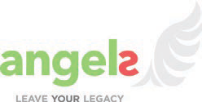
Major Sponsors

Websites Founders

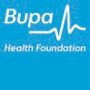
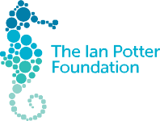
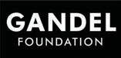

Supporting Sponsors
› Australian Physiotherapy Association
› Ipsen
› Marmalade Melbourne
› NAB Community
› Nicolab
› Position Promo
› Servier
› Wisewould Mahony

In-kind Sponsors
› AUSactive
› Fresh Promotions
› MedAdvisor
› Pharmacy Guild of Australia
› ProductLink

Businesses
› AFRM Claims Advocacy
› Arnold Bloch Leibler
› Blue Label
› Bupa Care Corner
› Bunnings
› Corrs Chambers Westgarth
› Fired Up Group
› J.J Richards Waste & Recycling

› Pepperstone Group
› Ritchies Stores
› RMBL Investments
› Ryman Health Care
› Silverline Medical
› Total Window Concepts
› Women in Insolvency & Restructuring (QLD)
› Yardstick Advisory
› Yieldbroker

Trusts & Foundations
› Annie Danks Trust
› Barr Family Foundation
› CommBank Staff Foundation
› Erica Foundation
› Newcastle Permanent Charitable Foundation
› The Elizabeth & Barry Davies Charitable Foundation
› The Lionel & Yvonne Spencer Trust
› The William Angliss Charitable Fund

Continued over page

Stroke Foundation 29

Government
Australian Government
› National Disability Insurance Agency (NDIA)
› Information, Linkages and Capacity Building (ILC)
› Department of Industry, Innovation and Science – Medical Research Future Fund (MRFF) Emerging Priorities and Consumer Driven Research (EPCDR) Initiative
› MRFF Cardiovascular Health Mission
› Department of Social Services

Government
› Australian Capital Territory Government
› Queensland Health
› Tasmanian Department of Health and Human Services
› Australian Department of Health
› New South Wales Department of Health

Local Government
› Maroondah City Council

30

Stroke Foundation

Health and Charity Partners
› Cancer Council Victoria
› Cochrane Australia
› Diabetes Australia (Queensland)
› Murdoch Children’s Research Institute
› National Heart Foundation

Key Alliances
› Australian Chronic Disease Prevention Alliance (ACDPA)
› Australian Living Evidence Consortium
› Australian Stroke Alliance
› Australian Stroke Coalition
› National Hypertension Taskforce
› World Stroke Organization

Gifts in Wills Supporters
We were grateful for the kindness of the many Australians who saw fit to leave us a donation in their will this year.
› Allan Rowling
› Ann Gray
› Anne Hoareau
› Anne Meyer
› Beryl Hume
› Betty Young
› Bruce Carroll
› Darryl Simpson
› David Trevillien
› Delores Tennant
› Denis Klein
› Donald McAdam
› Dorothy Johnson
› Edward Hawting
› Eric Forster
› Faye Mansfield
› Frederick Lomman
› Geoffrey West
› Helena Wright
› The Late James Fairfax AC
› Jeanette Alfredson
› John Child
› John McClenahan
› Kathleen Schwager
› Kenneth Merry
› Len Grasso
› Lenard O’Shannassy
› Leslie Maurer
› Lilian Patterson
› Lindsay Hurford
› Margaret Nolan
› Marguerite Winkley
› Mary Halliday
› Merle Barker
› Mrs Matheson
› Noela Bebbington
› Nola Bren
› Peter Siminton
› Richard Graham
› Rita James
› Robert Donnan
› Robert Maynard
› Robert Friend
› Russel Watson
› Stanley Pendall
› Sybil Beresford-Long
› Thelma Cole
› Thi Ly Van Hessen-Dao
› Valda Clarke
› Valma Cox
› Wendy Verwayen
› Wendy Burcher
› Wendy Bidgood

Major Donors
With sincere gratitude to the individuals and families playing a leading role in supporting game-changing advances in stroke for survivors, their carers and families, health professionals and researchers.
› Mr and Mrs Geoff and Robin Aubourg
› Will & Dorothy Bailey Charitable Fund
› Mr and Mrs Leo and Ann Browne
› Jack and Hedy Brent Foundation
› Ronald Alan Curry Trust
› The Edward C Dunn Foundation
› Dr Michael Gronow
› Dr Margaret Harding
› The Halifax Foundation
› Kingfam Foundation
› J & E King Family Foundation Limited
› Mrs Sylvia Miller
› Graham and Pam Nock Foundation
› Mr and Mrs David and Glenys Overton
› The Henry Pollack Foundation
› Annie & John Paterson Foundation

› The Sun Foundation Pty Ltd
› Miss Jane Rich
› Ms Enid Swain
› Lady Marigold Southey AC
› Ms Jennifer Tatchell
› Mr James Tait
› Ms Marietta Tooher
› Wheatley Family Foundation

Counterstroke Golf Classic Committee
› Elizabeth Cotton (Co-Chair)
› Caroline Ennels (Co-Chair)
› Dee Clements
› Gail Long
› Hilary Yencken
› Ross Eddy
› Paula Barton

Major Community Fundraisers
City2Surf 2022
› Holly Gibbons
› Damian Muldoon
› Sophie Glew
› Priya Sharma

Run Melbourne 2022
› Ken Lyons
› Lisa Murphy
› Catherine Kealy

Blackmores Sydney Running Festival 2022
› Nick Starr

Runaway Noosa Marathon 2022
› Ben Wall

Bridge to Brisbane 2022
› Archana Sinh
› Paige Fraser

Fundraise4Stroke
› Tommy Quick
(The 4 Points Australia)
› Nick Beever (Nick’s 21k for 21k)
› Claire Thompson (SistersForStroke)
› Peter Scott
(My Half Marathon)
› Nicola Baker (Moyamoya Australia)
› Sara Khaiami
(39 is the new 40)
› Gail Jaensch (Portland Waterfront Cabaret)
› Nikki Gower-Langbein (Bendemeer Stroke Foundation Fundraiser)
› Teagan Richards (Teagan is shaving her head)
› Arthur Cheetham (In memory of Dawn and George Hardy, Josie, Colleen, Corrie and Marge)
› Luke Barker
› Hannah Brereton (Longley International Hotel’s Halloween Fundraiser)
› Charlee Parr
› Matthew Azar (Michael’s Charity Golf Day)
› June Hicks (Goodwin Aged Care Market Day)

Stride4Stroke (Individuals)
› Lee Carseldine (Ambassador)
› Nic Hinwood
Stroke Foundation
31
› Tracey Laverick
› Edwina Elliott
› Linda Thompson
› Dee Banks
› Kathie Kenyon
› Deborah Cottle
› Heidi Victoria
› Naomi Mallin
› Matthew Francis
› James Knight
› Mal Jacobsen
› Glenn Browne

Stride4Stroke (Teams)
› TWM Stride4Stroke 2022
› William Siegel’s Bitumen Bashers
› Do it for Dave
› Little Stroke Warriors Community
› One Rehabilitation Service
› AbbVie
› Sister Tribe
› Pezet Pacers
› i-REBOUND Team
› STARS4Stroke
› Rocks Riverside Runners
› Cazz’s Stroke Journey
› Second Chances
› Rehab Warriors Tasmania
› Jaunt4Jayne
› Team Heidi Victoria
› Team Tahnee
› Sherree’s Striding for Stroke
› Harry’s Honour

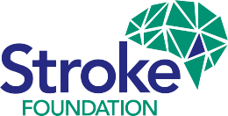

Stroke Foundation would like to thank the many thousands of people who have generously donated their time and money to ensure we are here to support all Australians whose lives have been changed by stroke.

Contact us
1300 194 196
strokefoundation.org.au /strokefoundation
@strokefdn @strokefdn
How to get more involved
Give time – become a volunteer.
Raise funds – donate or hold a fundraising event.
Speak up – join our advocacy team.
Leave a lasting legacy – include a gift in your Will.
Know your numbers – check your health regularly.
Stay informed – keep up-to-date and share our message.

